Name: Dylan Stevens BLK: D
Penny Lab
Purpose: To determine how many drops of water fit on one side of a
penny.
Hypothesis: If the soap solution placed on the penny decreases the surface cohesion, then the penny will hold less drops of water because soap reduced surface friction weakening the hydrogen and oxygen bonds.

Materials:
100 ml of soap solution, 50 ml of water, 8 Canadian pennies, 4 paper towels, 1 pair o forceps, 1 dropper

Procedure:
Part A: Perform a CONTROL test for comparison with later results.

Step 1: Rinse a penny in tap water and dry completely.
Step 2: Place the penny on paper towel.
Step 3: Use an eye dropper to place drops of WATER on the penny (one at a time) until ANY amount of water runs over the edge of the penny.
Step 4: Record the number of drops for that trial in the table.
Repeat Steps 1 - 4 three more times before calculating your average.

Number of drops  TRIAL 1 | Number of drops  TRIAL 2 | Number of drops  TRIAL 3 | Number of drops  TRIAL 4 | AVERAGE Number of drops
27 | 24 | 23 | 29 | ~26

Part B: Perform tests with the TESTING LIQUID.

Step 1: Start with a “clean” penny. Rinse the penny in tap water and dry completely. Be sure to remove as much residue as possible - without using soap!
Step 2: Hold the penny with the tweezers provided, then dip it into the TESTING LIQUID. Allow extra liquid
to drip off the penny into the container before proceeding to the next step.
Step 3: Place penny on dry spot on a paper towel. Place drops of WATER on the penny (one at a time) until ANY amount of water runs over the edge of the penny.
Step 4: Record your observations and the number of drops for that trial in the table.
Repeat Steps 1 - 4 three more times before calculating the average.

TRIAL 1 | TRIAL 2 | TRIAL 3 | TRIAL 4 | AVERAGE
7 | 2 | 6 | 9 | 6
Observations:
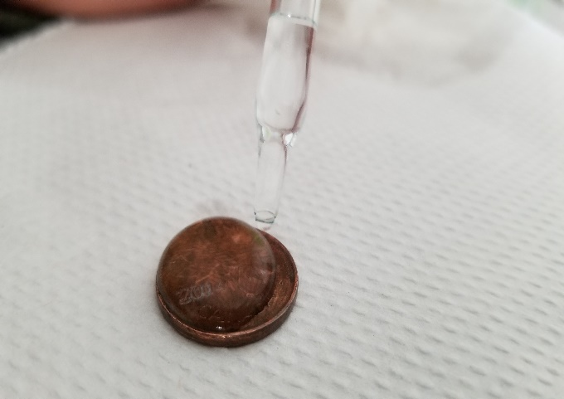  Part One: Labelled Diagram of observations:  Water in the dropper  Water drops building up  Paper towel  Penny | Part Two: Labelled Diagram of observations:  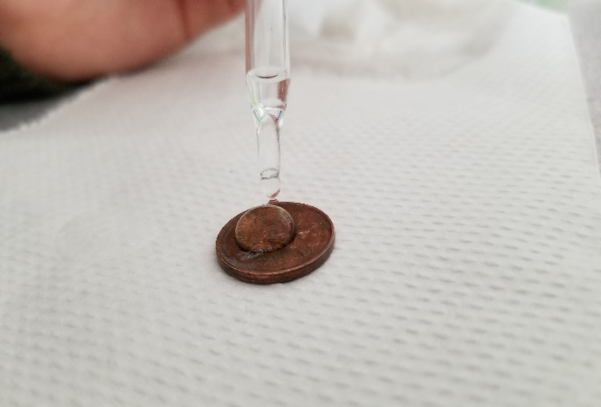  Penny With  Soap
Results:
Group # | Average Number of water Drops on the Control Penny | Average Number of Drops on the  Penny submersed in the soap solution
Group One | 20 | 9
Group Two | 25 | 8
Group Three | 26 | 6
Group Four | 23 | 7
Group Five | 22 | 9
Group Six | 14 | 5
Class Average: | 22 | 7

Conclusion:
This experiment investigated the different strengths of oxygen and hydrogen bonds by soaking a penny in different liquids.
To study the problem, an experiment was conducted using four trials of dropping water onto four different dry pennies and counting the number of drops until the water ran off the sides. Then the second part of the experiment was conducted with the same process of counting drops of water, however this time with the pennies soaked in the independent variable, soap.
Results showed support for our hypothesis, in that the average drops for the soap pennies was significantly lower, ~77%. This proves that soap does in fact reduce the strength of oxygen and water bonds. For the most part, the results showed all groups had very similar results, except for one. The soap had material in it that when between the water and penny molecules, reduced friction, giving it a slippery feel. 2 possible reasons for the large difference of one group, could be the force in which the dropper was used, or distance between the dropper or penny, that the water drops fell.

To extend this experiment different independent variables could be used such as juice, detergent, oil. Different coins could be used made with different materials that may or may not have different surface tensions.

This experiment could be, and has been used in real life to show the use of soap, and how it functions. Dish soap is a very useful tool in practically every household used to clean dishes by hand. Since the soap reduces surface friction and molecule bond, when combined with water against a dirty dish, it is extremely effective at taking off dirt particles.

Finally, if the experiment was repeated, some changes to improve the experimental design could be to do it on a stable surface or with other types of soap.
Questions :
How are the bonds weakened? What is the reaction with liquid that is not water?

Post 2 photos (penny with water only and penny with testing liquid) and your conclusion to your edublog site. Tag “Science10pennylab_Feb2018”

