Digital Footprint
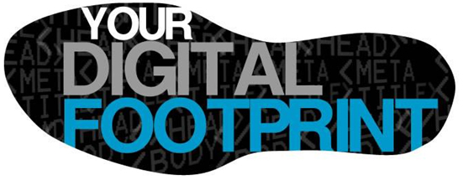
How might your digital footprint affect your future opportunities?
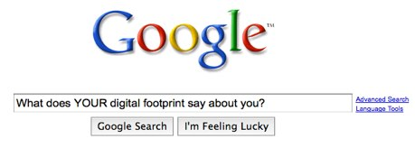
Digital footprints are very important as it is your reflection of everything you have done digitally. Every comment you make on social media or video you post on YouTube can be traced and used to view the kind of person you are. When you are searching for jobs there have been many cases of people with negative digital footprints being denied a job when other from that, they would have been a perfect employee. For example, if you posted inappropriate or vulgar things on Facebook, and you went for a teacher interview, there could be multiple reasons why you wouldn’t be eligible. However, if you happen to have a very positive digital footprint, your chances and opportunities of employment skyrocket.

Three strategies that you can use to keep your digital footprint appropriate and safe.
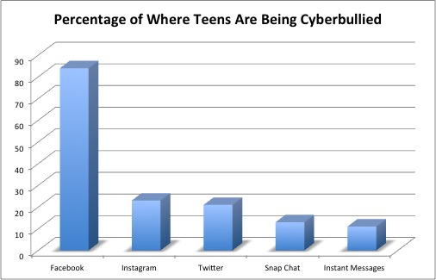
Think twice before you act online. Its very easy is to get caught up in a situation where something either made you angry or possibly you saw something that was against your opinion where you immediately thought to say something back. But before you say anything that could be a regrettable mistake online you should ask yourself, “What do I want my future to look like?” Especially with cyberbullying becoming more of an issue.

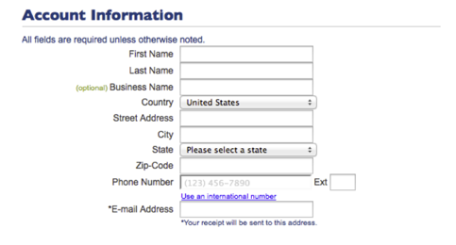
Don’t give away too much personal information. With the internet more expansive than ever, it is entirely possible for someone to find out where you live, your name, what you do for a living, etc., even if you don’t think you’re even giving away anything it can still be found somewhere. Do yourself a favor and don’t give away anymore than there already is. For example, when your signing up for a new website or social media make sure things like your province or country (if they’re not optional) are kept private by the website.
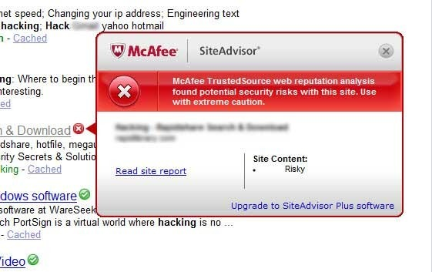
Use an online safety software such as McAfee, or Bitdefender to protect you from illegal browsing online. Its very easy to accidentally end up on a website you probably didn’t think, or know was illegal and in some cases possibly even get charged or arrested. Things such as streaming movies illegally, or downloading free music can and most likely will be put on some kind of record if you are doing it illegally and whether or not it is that serious it could still possibly affect your future.

Information that I would pass on to other students.
In my opinion the internet is a great place where you can do a lot of things, however it is easy to get caught up thinking that just because you can’t physically see people you are talking to, or wont necessarily see any physical damage, that you can get away with a lot more. However, it is just as easy, if not easier, to have that affect your future. In the end however, if you use the internet responsibly it is a great tool.
Bibliography:
N.d. Web. <http://langwitches.org/blog/wp-content/uploads/2009/09/Google-digital-footprint-1.jpg>.
N.d. Web. <http://learnbloggingnow.com/wp-content/uploads/2015/08/how3.png>.
N.d. Web. <http://mediad.publicbroadcasting.net/p/prndi/files/201312/DigitalFootprint.jpg>.
N.d. Web. <https://images-eu.ssl-images-amazon.com/images/I/61CrPQ%2BNPEL.png>.
N.d. Web. <https://screenshots.en.sftcdn.net/en/scrn/48000/48307/mcafee-siteadvisor-14.jpg>.
N.d. Web. <https://upload.wikimedia.org/wikipedia/commons/8/87/Where_Cyberbullying_Is_Occuring.jpg>.

