National U.S.A Times Posted: November/23/1956

Andy Davis: taken in May/15/1954
16-year-old boy named Andy Davis was found dead by his girlfriend, Laura in the alley near Afredo’s at 12 in the morning in New York. The victim seemed to be murdered by getting stabbed in the rib cage and left bleeding to death. By the purple jacket left near the body, he was seemed to be a Royal. Subjects were expected to be The Guardians, who were the Royal’s allies. Known witnesses were Laura, Freddie and Angela.
“He left to buy cigarettes at Afredo’s at 11:30. When it was past midnight, I got worried, so I went to go look for him, when I went to the alley, I saw his body there. I thought he was still alive, so I ran to a police officer, but by the time we got to Andy, he was … dead. Look I know he’s a Royal, but he doesn’t deserve to die. He was really a nice and caring guy” said Laura
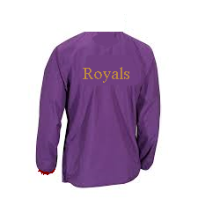

Royal Jacket found near body

“Me and my girlfriend were just walking down the street until we saw Andy laying on the ground bleeding. I went to help him until I saw his jacket and knew that he’s a Royal. Angela and I don’t want to be involve with them and the Guardians, so we left them there.” “Yes, it’s sad that he died” said Angela “but I just want to go home and not be involve with the Guardians”.
There wasn’t enough evidence to find the killer and he was still on the loose; so, if you’re a Royal, try to be safe.

