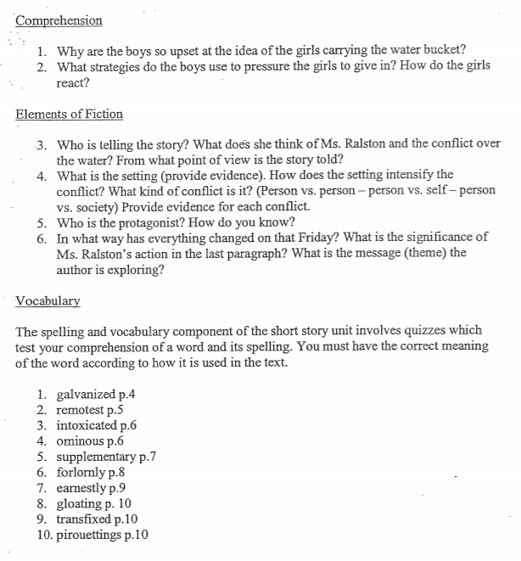

IDK

Girls because we know them

At school person vs person

A girl and 3rd person limint

That girls are weak and the girls were angry at it

Cause their boys