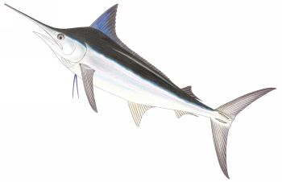
MARLIN
which one should one consume?

Approved Marlin species for consumption:
Blue Marlin (Makaira nigricans):
- Wild, Longline.
- Location: Hawaii
- Overall Rating: 2.9-3/5

Not recommended for consumption:
Black Marlin (Istiompax indica):
- Wild, Pelagic longline
- Location: North Pacific, South Pacific, Western Central Pacific.
- Overall Rating: 0.0-1.8/5

Striped Marlin (Tetrapturus audax)
- Wild, Pelagic Longline
- Location: North Pacific, South Pacific, Western Central Pacific.
- Overall Rating: 0.0-1.9/5

Blue Marlin (Makaira nigricans)
- Wild, Pelagic Longline
- Location: North Pacific, South Pacific, Western Central Pacific.
- Overall Rating: 0.0-2.0/5

-Ocean Wise

