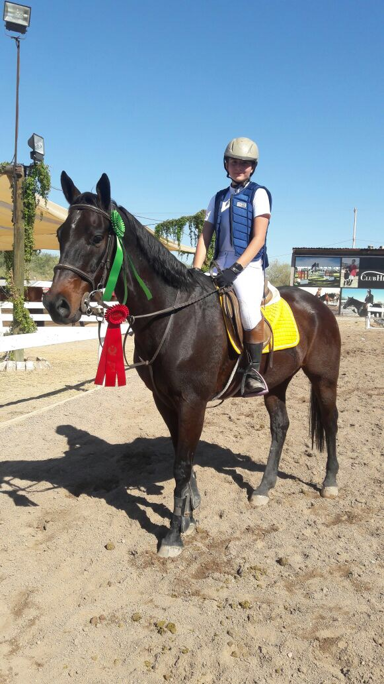
Genesis
Hot. That’s how you feel. Burning, melting on the summer’s sun. The sun with its imposing light punishing the earth and everything living in it. The wind howling in your ears, you hear nothing but the whispers of the wind. Burning old wind. The hitting sound of hooves resonating on the walls around you. A repetitive sound of your harsh breathing, the bigger breath under you as strong and consistent as your movements. Far away you hear a voice, muffled by the other sounds, the greedy wind overpowering all the other sounds, but that sound fight and reach you; light and small but with power, it lures you and controls your body. Right, left, circle, turn, jump, stop, it has a confidence one cannot fight. But your ears get tired, and you start to smell.

The smell of damp earth below you. The scent or sweat, fear and anxiety; the scent of your past and of life; big, strong and glorious life. Your nose gets tired by your desperate tries to fill yourself of oxygen, your hands hurt by the rough leather trying to scape from your grip; you want to give in and free your hands from their torture, sadly if you let go, all your control goes with it, you will not be able to keep going and you will fall. Your legs try to grab themselves to the saddle, they are strong but time goes by and they grow weaker, they start to shake so hard fighting for control. Your feet push down, your knees squeeze and your head looks up, the back stay straight and the body rocks with each movement.

Your eyes are set on the opponent, one after the other while the body prepares and the mind starts to think of the next one. You feel confident; you have just beat seven opponents and keep going, you’re winning. Suddenly, on the eight everything changes. Fast. You need to go faster. Time is eating you. Now you are not only fighting against the obstacles, but with yourself and with time. Unforgiving cold time. The feeling on your hands, the fatigue in you legs, the smell of the earth, and the whispers of the wind. All of that goes away, they pack their bags and don’t even set good bye. They have been thrown out by the overpowered sound of your red engine, going faster every beat. Nothing else matters; not the pain, the people, not even the imposing voice.
You forget everything on speed, you barter, giving away your order and control. You don’t think. Then you see your last opponent and advance with confidence thinking it would go down just as the others. Your partner doesn’t think the same; he knows you have forget about everything else and decides you are not prepared for it, he got tired of doing all the job and decides not to fight. You feel your partner leaving you all alone, but he was right, you were not ready, not to fight or to stop your partner from leaving. So you fall, you lose against your partner exactly as you lose against your opponent.
Your engine overworks and fails; your legs give in to the fatigue; your ears start to listen again, to the music and the screams of people, but your brain doesn’t care because your hands give in too, they finally leave their punisher. The engine gives one last beat as you fall, time looks cunningly at you while you fall so slowly really fast. You see your partner run away as your body touches the floor, the damp earth gets all over you and you remember its smell.

Everything stops, you just lost. Nothing moves. Time freezes for a little longer. Then you hear it, a sound embodied in your brain as failure, the cry of elimination; everything starts moving again, you get up just as time continues its normal course. You have failed, again, and you think of that as you try to clean yourself of the dirt on your way to grab your horse. You walk back to the stables and leave him there, you know it wasn't his fault, you could have made him jump if you had more control and a cleaner mind, but it was blocked with the thought of being the fastest and winning the competition.
It will be okay. You decide to try again next time as you go back to your friends and teacher to finally eat something. It’s okay, you say to yourself with a heavy heart, winning is not everything and there is always next time. So you sit with your sadness and fill it with food. Next time, you say.

