
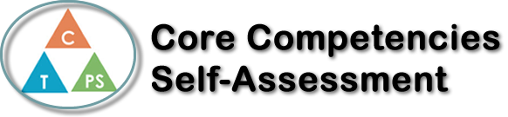
Name: David Magnusson | Date: 16/01/2023

  How does the artifact you selected demonstrate strengths & growth in the communication competency?  In what ways might you further develop your communication competency? | Self-Reflection  Describe how the artifact you selected shows your strengths & growth in specific core competencies. The prompt questions on the left - or other self-assessment activities you may have done - may guide your reflection process.  In my Pre-Calculus 12 class, we have had a fast-moving class with many lessons being crammed into a single semester. Every day, when we’re not doing a test or quiz, we are learning a new lesson in thr workbook, and then applying the new mathematical concepts to our previous lessons and units, such as that with Trigonometry and using Radians instead of degrees (which was a new lesson for me this year), and growth and decay formulas being applied to real-world scenarios and situations.  While the tight schedule is a feature of the course, it’s still difficult to fully learn and apply the lessons properly before each test, and my success in the course is a testament to my discipline in using all the available information and study material to correctly study and learn the substance of the course.  My personal awareness and responsbility competencies have grown in how I recognize and adapt to learn quicker and cover more course material at home and in how I adapted to the tighter schooling schedule to successfully keep my grades high.  -“I can take ownership of my goals, learning, and behaviour.”  In taking charge of my learning and developping my discipline and skills, I’ve pushed my goal ceiling upward and have become more prepared for the next steps in life.


How does the artifact you selected demonstrate strengths & growth in the thinking competencies?

In what ways might you further develop your thinking competencies?

X

How does the artifact you selected demonstrate strengths & growth in the personal & social competencies?

In what ways might you further develop your personal & social competencies?

Publish Your Self Assessment
You will now attach and/or embed your self-assessment to the bottom of the blog post with the artifact you have chosen. You may choose to make this post private or public. After placing your artifact on a blog post, follow the instructions below.
- Categories - Self-Assessment
- Tags - Now tag your post using the tag that corresponds to the competency that you have written about. You can choose more than one. Please use lower case letters and be exact.
  - #creativethinkingcc
  - #communicationcc
  - #criticalthinkingcc
  - #socialresponsibilitycc
  - #personalidentitycc
  - #personalawarenesscc
- Use the Add Document button located at the top of your post page and embed your self-assessment at the bottom of your blog post.
- Publish

