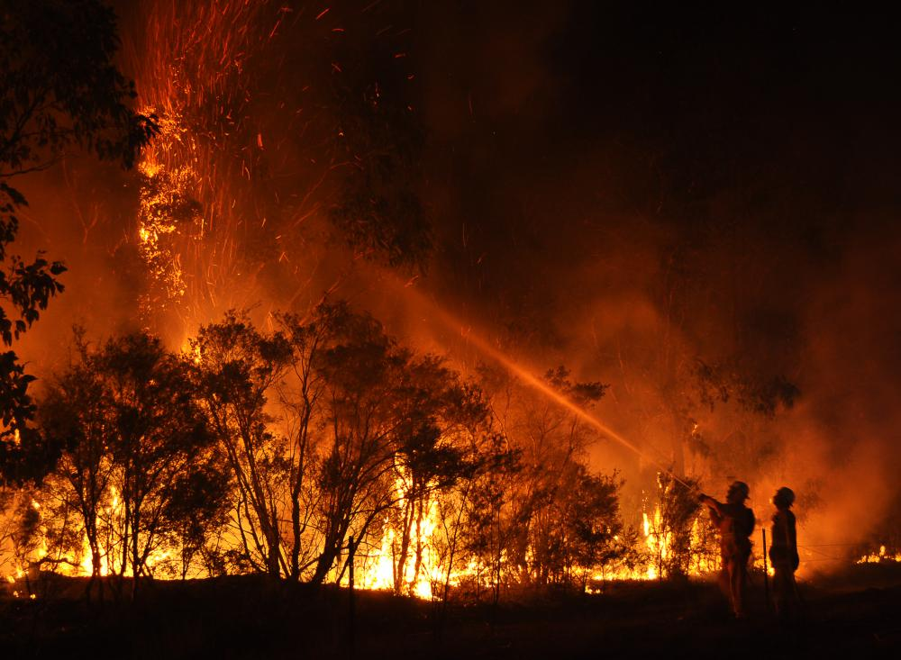
A burning appliance was left in a forest by the Cessnock town of Aberdare, response teams have been trying to combat the forest fire in the air and on foot. During one of the nights it began to rain and the fire slowly started to subside.
https://www.climatevisuals.org/node/973

https://www.nbnnews.com.au/2019/03/06/out-of-control-fire-burning-near-cessnock/
^^^^^^^^^^^^
The evidence is all too real

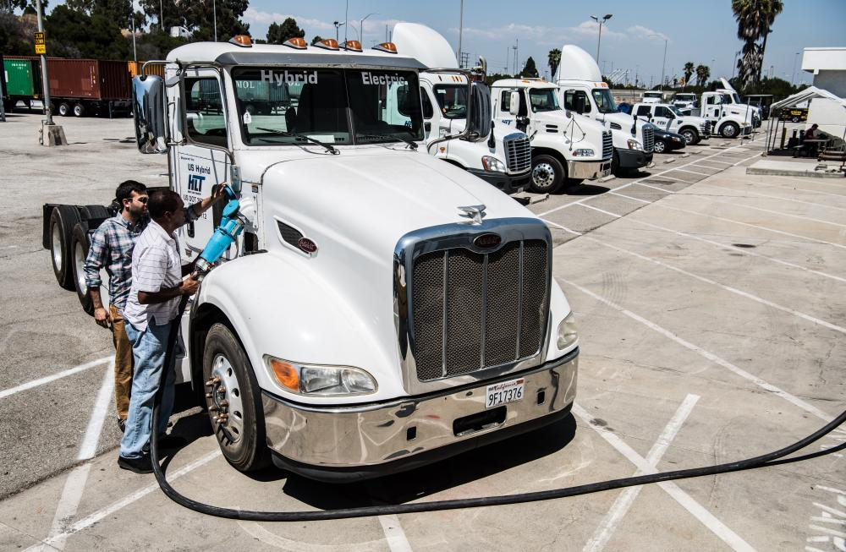
Our research suggests that showing real people engaged in 'everyday' scenes can be more powerful than staged photo-ops. Here two people are normalizing a climate solution in an ‘everyday’ image.
https://www.climatevisuals.org/node/1039

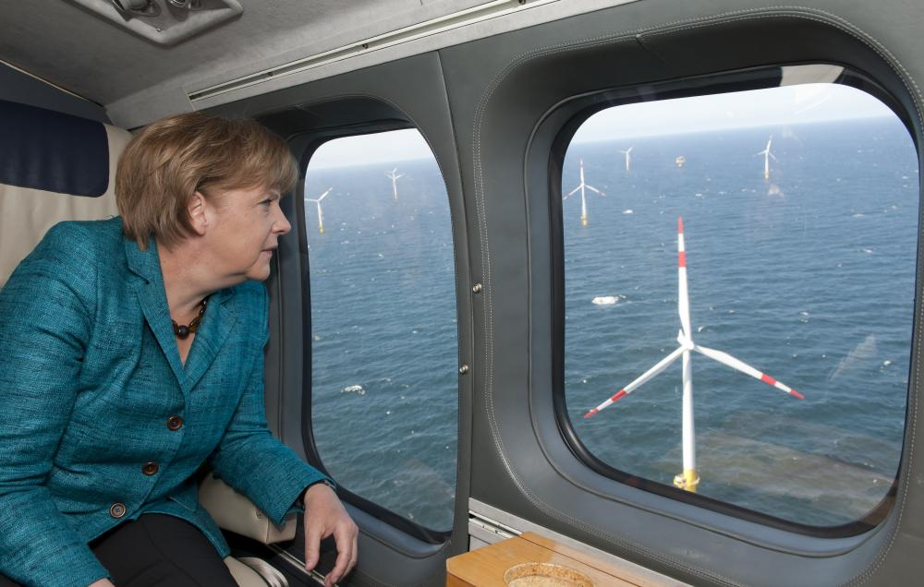
Although images of politicians received some of the lowest scores in our survey, this image of Angela Merkel (the German Chancellor) at least shows her actively engaging with the climate policies of her Government. Showing politicians doing 'something useful' is the best way of using them in climate imagery.
https://www.climatevisuals.org/node/983

