Ms. Ross Name: ____________
Socials 9 Date: ____________
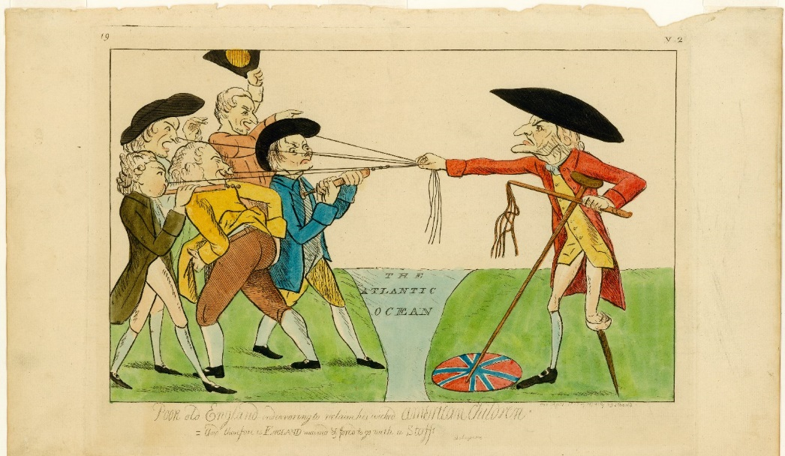
Analyzing Political Cartoons about the American Revolution

- What political cartoon devices are used?

- Who is the man on the right supposed to represent? What clues tell us this?

- Who are the ‘children’ on the left? What is happening to them? How are they reacting?

- What is the cartoonist’s message?

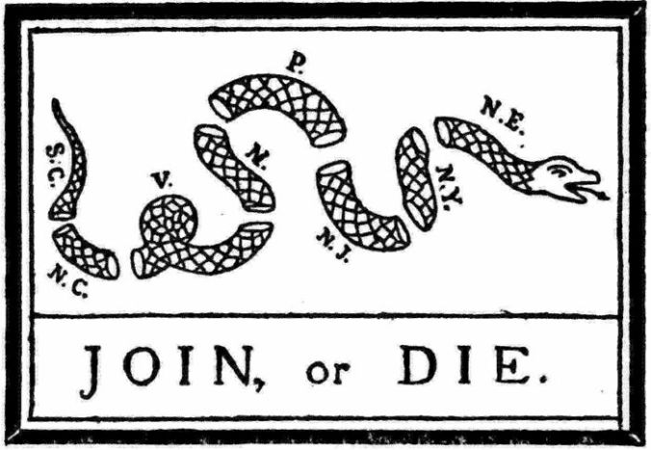

- What political cartoon devices are used?

- What are the segmented parts of the snake supposed to represent?

- What is the cartoonist’s message?

