Socials 9 Name: _______________
Ms. Ross Date: _______________

Chapter 5 - The Prairies 1870-1896

Please read pages 170-176 and fill in the blanks of this summary.
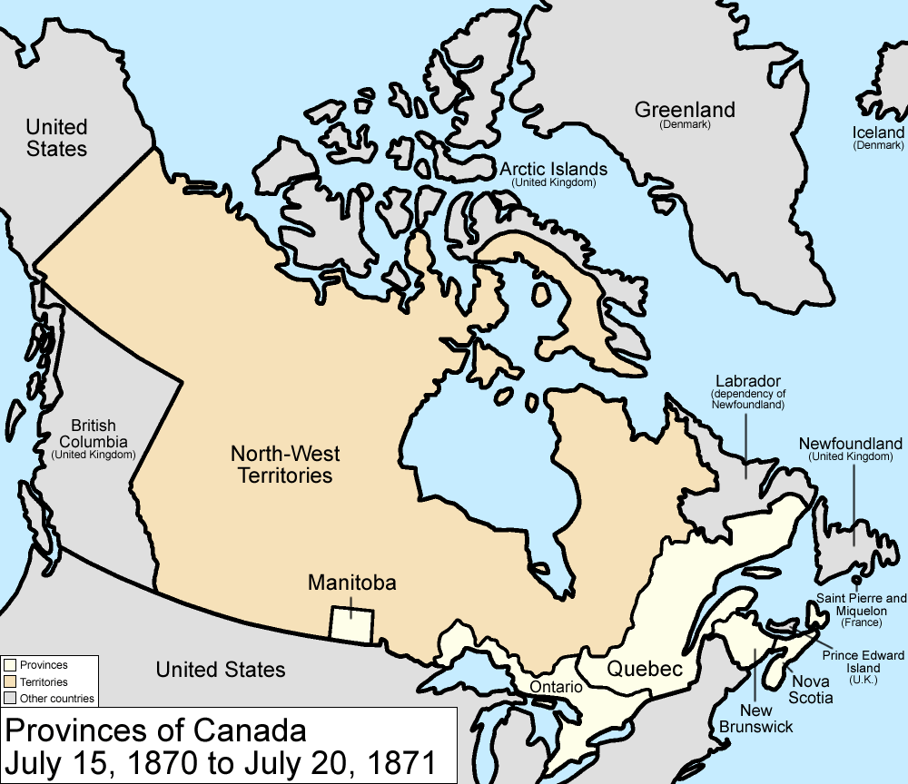
The __________ made up the majority of the population in the newly created province of ________________. They felt their rights would be protected by the __________________________ 1870: English and __________ were the two official languages, there would be two education systems (Protestant and ________________), and 1.4 million acres of land was reserved for the Metis for _________________.

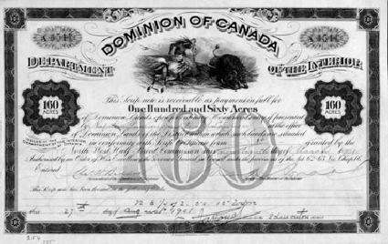
Troops that were sent by Prime Minister ________________________ to keep the peace in the region committed criminal acts against the Metis, such as arson, assault, rape, and murder, but were never punished for their crimes. To own land in the new province, you needed to have a piece of paper, a _________. There were two types of scrips given to the Metis. ____________ scrip had a value of _______ or $240 and could be converted to __________. __________ scrip could be exchanged for a homesteader’s land grant of 160 acres. The Metis did not understand the true value of the scrip: they didn’t realize this piece of paper was worth land or money and their culture did not use writing and paper to denote land ownership. In addition, the land that could be purchased with a scrip wasn’t always near established communities or rivers or suitable for farming; land was allotted based on a lottery system, so it was just ‘luck of the draw’. As a result, many Metis sold their scrip to _____________________________________ and were forced to leave Manitoba and settle in the _____________________.

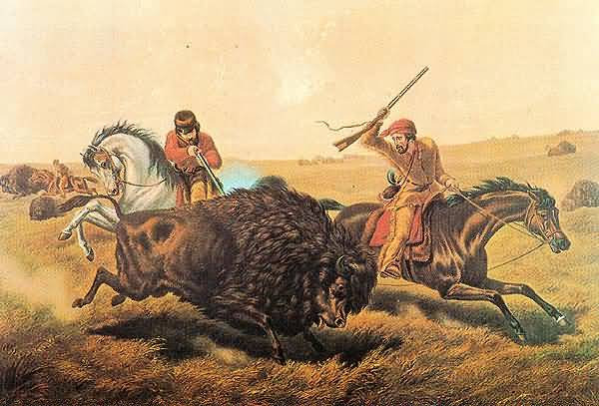
In the Northwest, the Metis re-created the life they had left in Manitoba. They farmed the land using the traditional ________________________ system and built churches so they could practice the Catholic religion. They earned a living through _____________________ farming (just growing enough food to feed the family), the ___________ hunt, and moving freight for the _______. Life was good until the buffalo hunt was threatened by encroaching settlement and farming plots. The bison herds, which once numbered in the thousands, were quickly ____________________. The First Nations and Metis relied upon the bison for their own existence, plus they traded hides and pemmican with the HBC. In response, the Metis created the ________________________________. These laws outlined settlement, farming, and hunting practices in the hopes of conserving the buffalo and the Metis way of life.

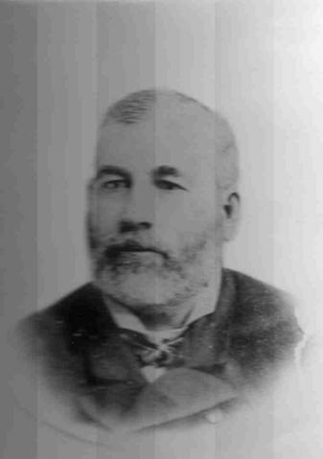
The HBC Chief Factor ____________________________ at Fort Carlton used the Metis for cheap labour. He only hired them for temporary contracts and gave them low wages, most of which were in the form of trade goods instead of cash. Clarke also became the _____________________, or judge, in the Northwest and this allowed him to maintain order in the region and advance the HBC.

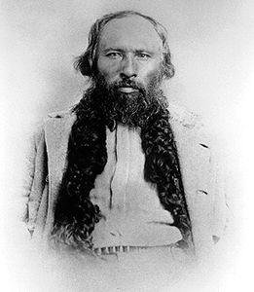
By the winter of 1874-75, the way of life of the Metis was in trouble. Almost all the bison had been eliminated, which meant a lack of ________ and ______________. In 1875, some Metis started the hunt earlier than others. ___________________________, the leader of the Metis in St. Laurent, arrested and fined them for illegal hunting. These men appealed to Chief Factor Clarke and he in turn arrested Dumont and his men! The Canadian government, under Prime Minister _______________________________, knew that Dumont was right and Clarke was wrong, but the government did not stop Clarke from abusing his powers in the region. Dumont and his men were fined, an act which made the Laws of St. Laurent invalid. This event signaled the end of ___________ control over the buffalo hunt. They could no longer make their own laws or govern their own livelihood.

WORD BANK

$160 Gabriel Dumont Manitoba
Alexander Mackenzie HBC Manitoba Act
buffalo income Metis x2
cash land money
Catholic land speculators Northwest
disappearing Lawrence Clarke scrip
farming Laws of St. Laurent seigneurial
food Macdonald subsistence
French magistrate

