Ms. Ross Name: ___________________
Socials 9 Date: ___________________
THE FUR TRADE
While exploring the world and looking for the fabled “Northwest Passage”, Europeans discovered that North America was full of resources. Trading European manufacturing goods for these resources became a lucrative business. While _______ was the #1 profitable resource, the ______ trade was a close second. For almost one hundred years one company had a _____________: complete control of a resource or service. When a new company came on the scene it provided competition that impacted both businesses and all those involved in the trade. While there were many differences in how these companies conducted business in the fur trade, there were a few similarities. The fur trade allowed for exploration of the continent and will be an important factor in settlements across the country. First Nations will be impacted both positively and negatively by the fur trade and arrival of Europeans.

The ___________________________ (HBC) and the _________________________ (NWC) were the 2 major players in the fur trade. What were the similarities between the 2 companies?

- Both traded ___________ fur pelts for European manufactured goods
- Both used the beaver pelt as a form of ____________ (money) for trading
- Both relied upon the wisdom and experience of ________________ to acquire the pelts
- Both were influenced by the __________________
- Both had to ____________ (change) to competition
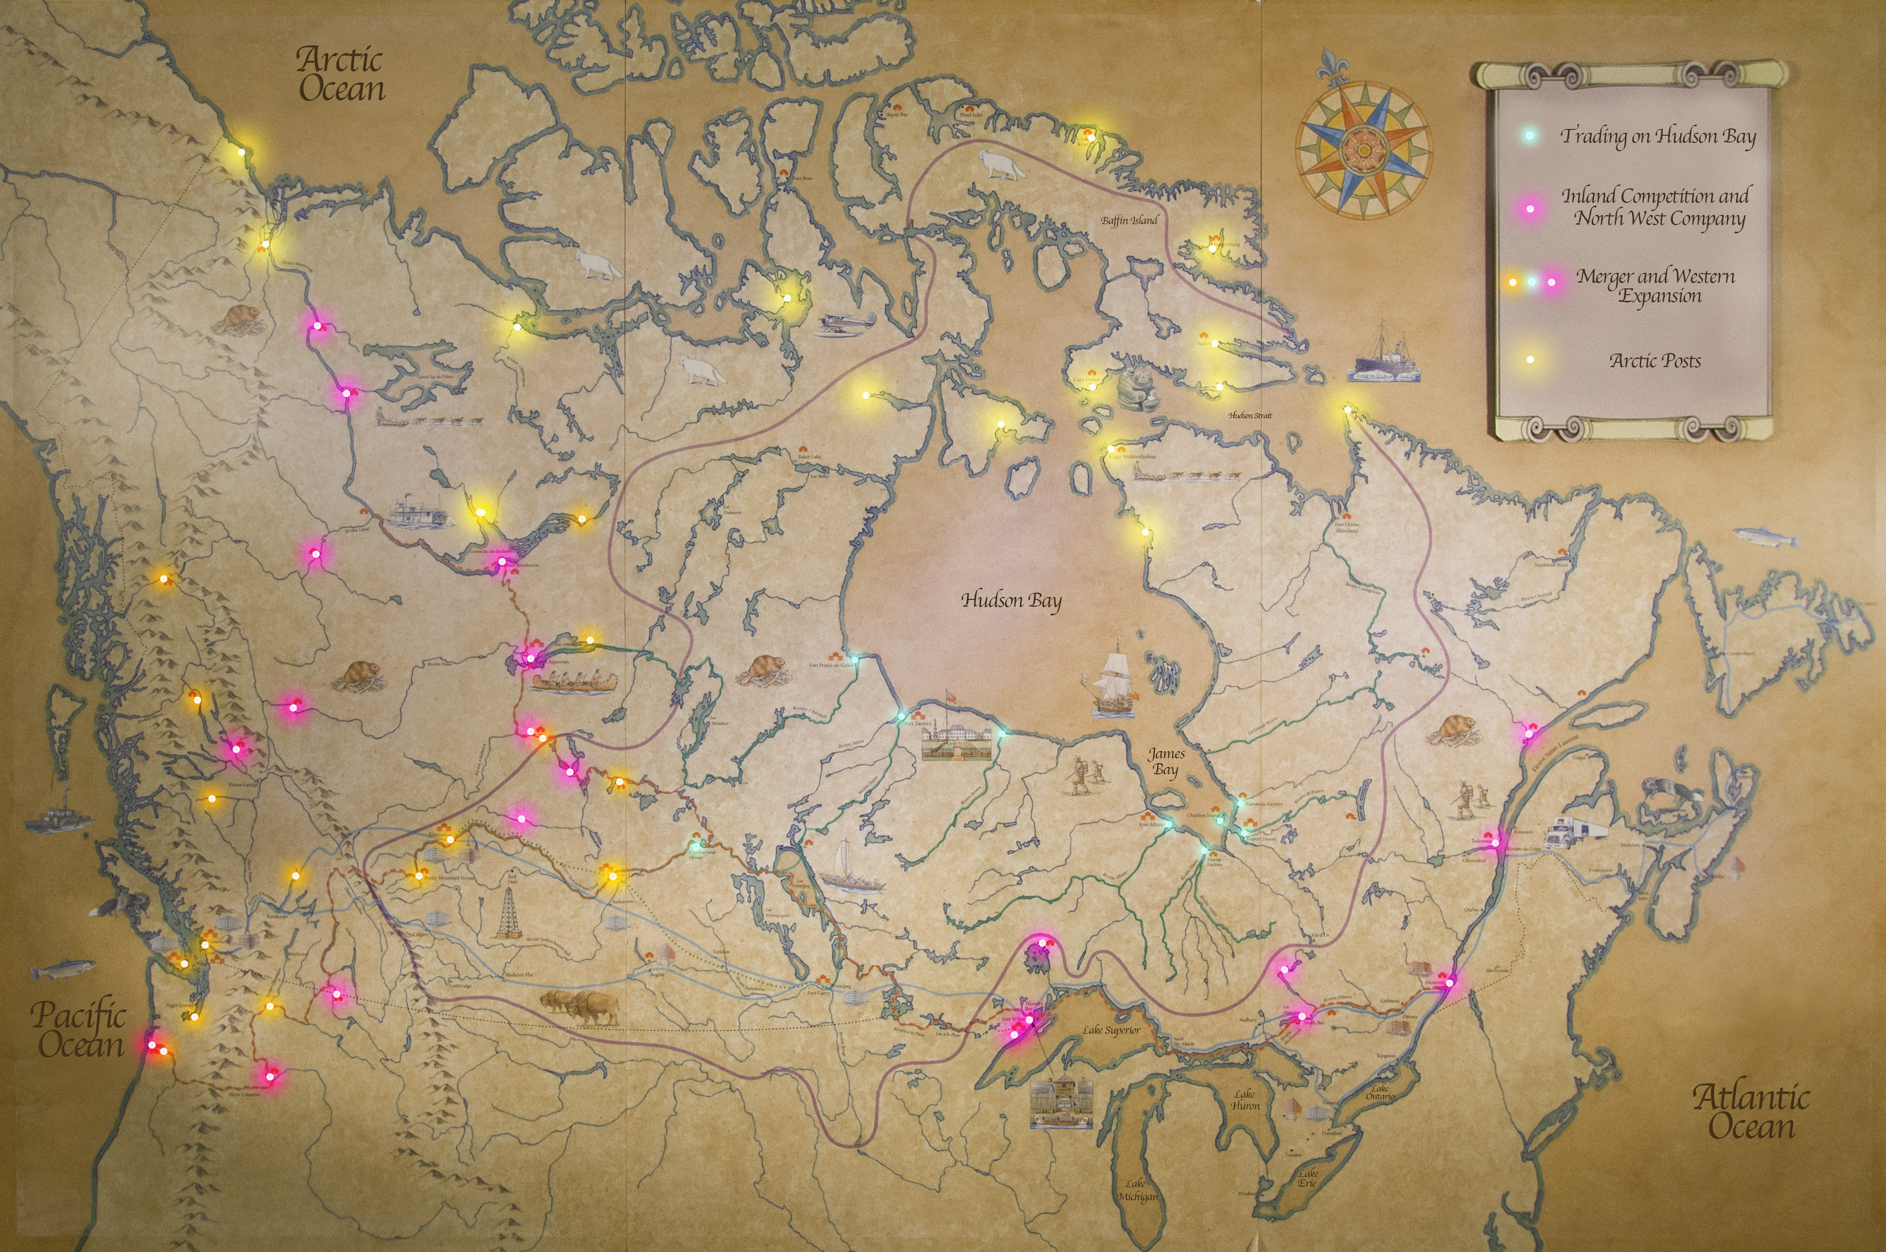

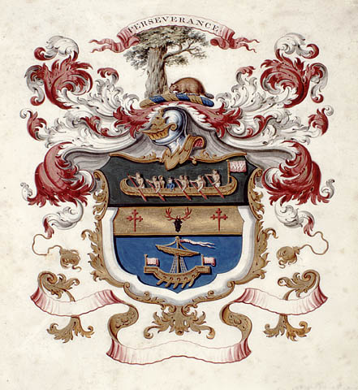
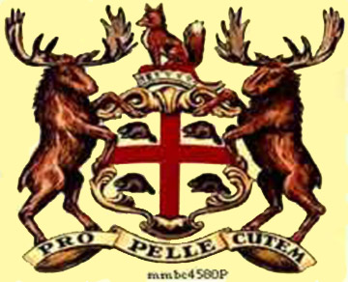

NWC emblem
HBC emblem

The HBC and NWC had a number of differences in how the companies were created, structured, and operated. Use pp. 126-131 in Horizons 2nd edition Chapter 4 to help you complete the chart.

 | Hudson’s Bay Company (HBC) | North West Company (NWC)
When was the company created?
Where was the business headquarters?
Where did they do business? | Def’n: land upon which all rivers drain into Hudson Bay | Throughout the
Where were their trading posts located? |  | Throughout the
Where was the main headquarters? | (on the shoreline of Hudson Bay) | (on the edge of Lake Superior)
Trading policy with First Nations | “________________________” = have First Nations come to them to trade furs | “We come to you” = NWC traders would go out and meet First Nations to trade
What type of transportation did they use?
Company organization | Strict hierarchy | Partnership
Workers’ pay | Salary | Commission
What was it like to work for the company? | -little chance to move up in the company  -no incentive to work hard  -boring as you had to stay at the fort  -safe because you were protected by the palisade walls  -had the company of family and friends | -chance to move up and become a partner  -incentive to work hard = more pay!  -excitement, adventure, exploration  -risky and dangerous  -lonely as you were away from family and friends for months at a time
What were their initial trading practices? | -set prices for trading  -____________ bargain  -___________ trade alcohol for furs | -prices fluctuated  -___________ bargain  -_________ trade alcohol for furs
What were the company rules regarding First Nations? | -___________________ employees to have relations with First Nations women  -only ___________ were allowed to marry | -___________________ employees to have relations with First Nations women  -________________ were allowed to marry

