
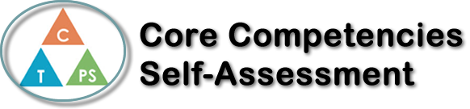
Name: Catriona | Date: April. 20, 2021

  How does the artifact you selected demonstrate strengths & growth in the communication competency?  In what ways might you further develop your communication competency? | Self-Reflection  Describe how the artifact you selected shows your strengths & growth in specific core competencies. The prompt questions on the left - or other self-assessment activities you may have done - may guide your reflection process.  In what areas, if any, do you feel your French has improved this quarter?  I think that my vocabulary has really improved this quarter. It still needs a lot of growth but, it is a lot more than I knew before now.  In what areas in French do you want to continue to grow?  I want to continue growing in my vocabulary and pronunciation because one of my weakest parts in French is pronunciation. I also want to grow in these areas because with these skill I would be able to have a decent conversation with someone in French.  Choose any aspect of the course that you are the proudest of this semester. Explain why you chose this aspect.  I am the proudest of my Tu seras une vedette project this quarter. I am the proudest of this project because I was using my new vocabulary and try to practice my pronunciation.  With my Tu seras une vedette project I was using my communication skills, critical thinking and personal awareness and responsibility. With that project it pushed me out of my comfort zone but, it had me do a project I do not usually do. My communication skills because of the oral component. Critical thinking because I had to figure out what I was doing for the project and ended up making up a fake reality for this project. Then finally my personal awareness and responsibility skills to put it all together and chose what I included in the project. It helps me strengthen my skills in French and in the core competencies.


How does the artifact you selected demonstrate strengths & growth in the thinking competencies?

In what ways might you further develop your thinking competencies?


How does the artifact you selected demonstrate strengths & growth in the personal & social competencies?

In what ways might you further develop your personal & social competencies?

Publish Your Self Assessment
You will now attach and/or embed your self-assessment to the bottom of the blog post with the artifact you have chosen. You may choose to make this post private or public. After placing your artifact on a blog post, follow the instructions below.
- Categories - Self-Assessment
- Tags - Now tag your post using the tag that corresponds to the competency that you have written about. You can choose more than one. Please use lower case letters and be exact.
  - #creativethinkingcc
  - #communicationcc
  - #criticalthinkingcc
  - #socialresponsibilitycc
  - #personalidentitycc
  - #personalawarenesscc
- Use the Add Document button located at the top of your post page and embed your self-assessment at the bottom of your blog post.
- Publish

