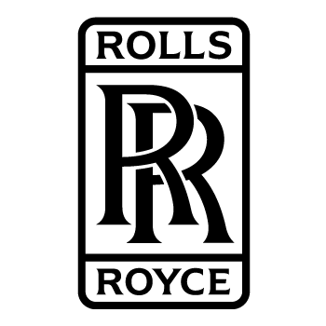
For the Community Connections project, I interviewed Jennifer Dadson. She is a mechanical engineer who went to Purdue University, has both her Bachelors and Masters, works for Rolls Royce as a project manager in the mechanical division and is based in Indianapolis Indiana. I had chosen to do an interview with her because she does exactly what I want to do.
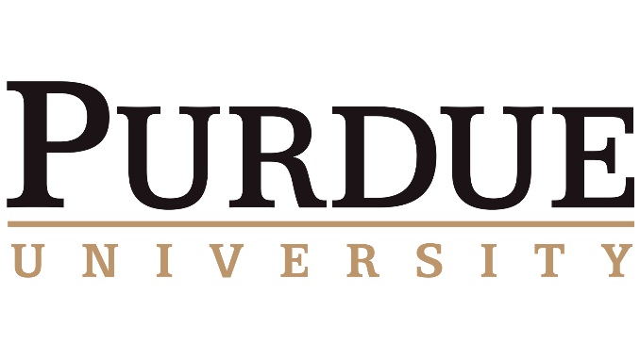
The first questions I asked her is Why are you passionate about your job? Her answer to that is she loves her job, she finds it challenging, there is always something new and she can see the impact of her work. When she gets on a plane, she can see what she designed or helped design.
Then I asked, what obstacles have you faced to get you where you are today? She thought the biggest obstacle she faced was going to school in the US and getting her first aerodynamic job there without citizenship. She found out that networking was one of the key things that she needed to get her job.
Then I asked, what advice would you pass on to someone interested in what you are doing? Because I want to be an aerospace engineer she said go to a school that has a good aerospace program, figure out what you specifically want to do and to maybe get another degree like a mechanical engineering degree because she is a mechanical engineer who gets to work on aerospace engineering and she knows other engineers who have degrees in different fields but, work on aerospace engineering.
The fourth question I had asked her was, what degree was harder to get her masters or her bachelors? She got both her degrees at Purdue University and thought that it was harder to get her bachelors because it was all classes while her masters was her favorite, she got to dive deep into experiments and mainly study one thing.
The last question I asked her was, what did she think the profession would be like in 10 years would it have changed, or be more less the same? She thinks that it will be changing a lot for at least the next 50 or so years. Everyone wants to go to mars, they want to be less reliant on gas and find other ways to power the planes and everything else, it’s constantly growing and there will be a lot more careers in the future.
With this interview I learned a lot more about the field I thought and what I would need to consider about going into the field. She told me about her own experience about going to school in the US without citizenship there, how had it is to find a job there is and how helpful it is to be good at networking. That’s it a lot easier to do your job if you enjoy it and that the field will probably be changing for quite a while. I have learned a lot from this interview and think that this opened me up to new ideas about my future.

