Nimbostratus Clouds
Just like the picture above, a nimbostratus cloud is a grey and low cloud that is dark widespread cloud with a formless layer. It usually produces continuous rain, snow, sleet, and no lighting or thunder.

Tuesday April 16th @2:12pm
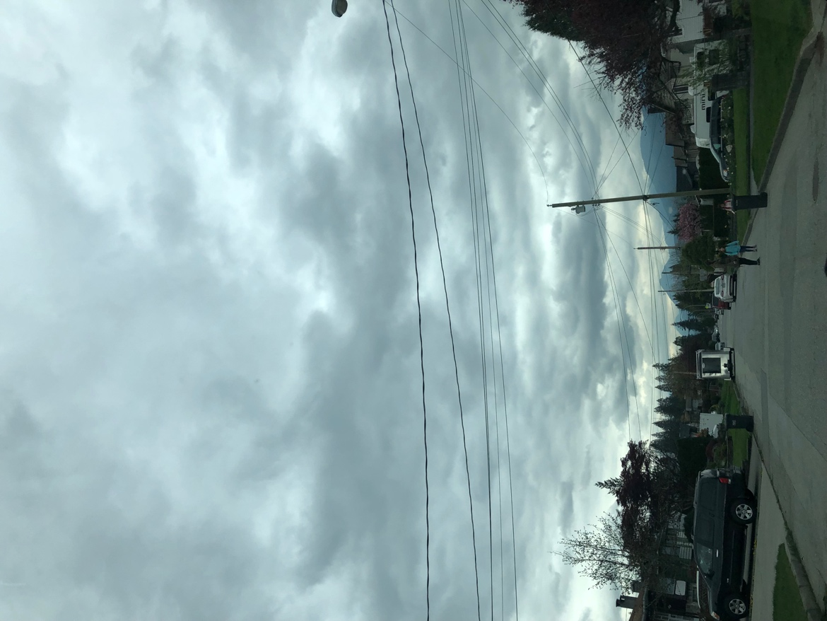
Altostratus
Altostratus clouds are mostly in the form of a featureless sheet of cloud but can be wavy as a result of wind shear through the cloud and it can also be fragmented with clear sky visible. The clouds in this picture are altostratus because they appear to look like a sheet or layer and the sun can usually be seen through them. If the clouds are on the thicker side, then it is possible for it to rain and if the rain persists then the clouds will change to nimbostratus.

Monday April 15th at 3:46pm
Cumulus Clouds
Cumulous clouds are clouds that have flat bases and are puffy on the top and sides, cumulus clouds may appear by themselves, in lines or in clusters. They can be formed from water vapour, supercooled water droplets or ice crystals, depending on the temperature. As seen in the picture above these specific clouds have flat bases and are puffy on top and appear in a line formation.

Saturday April 20th @2:12pm

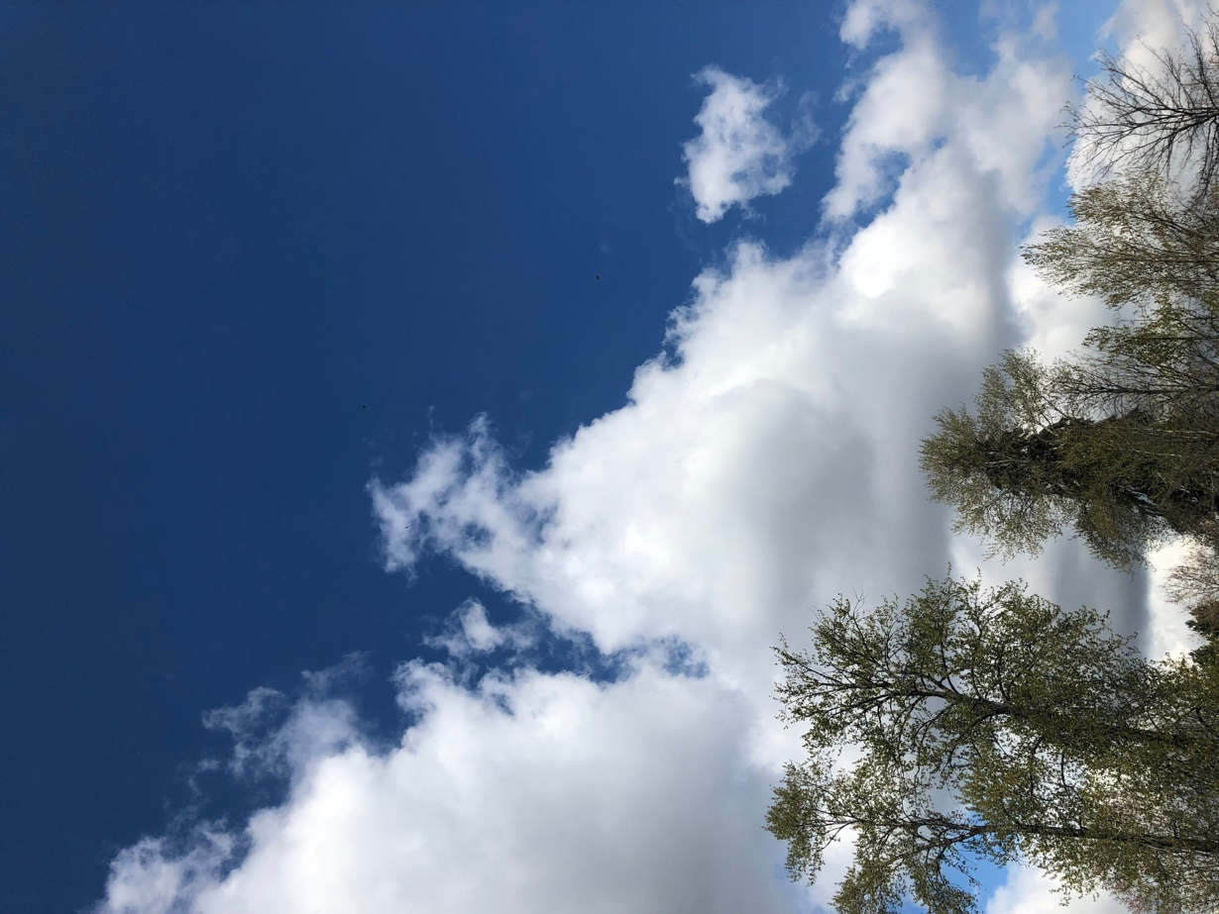

Towering Cumulus
In the picture above the clouds shown are towering cumulus because they are tall puffy clouds that go upwards in the sky. Towering Cumulus clouds are a specific form of Cumulous clouds. They appear as sharp outlined clouds with great vertical development. The towering cumulus clouds have the same formation process as normal cumulus clouds, but these specific ones have an impressive vertical development in the areas of deep, moist, convection.

April 12th @2:04pm

