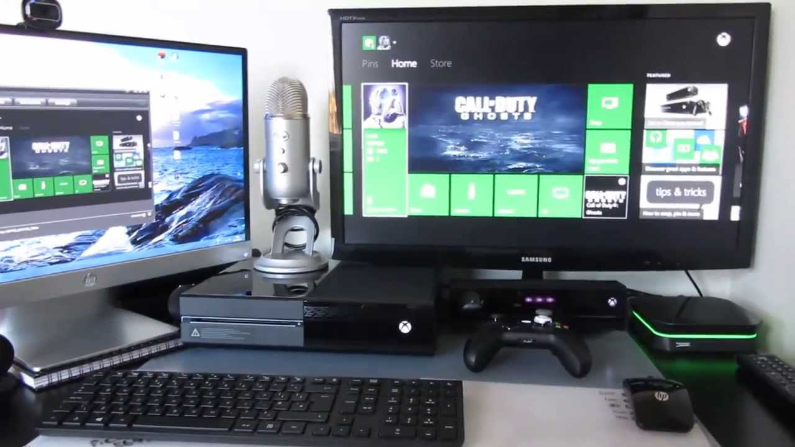
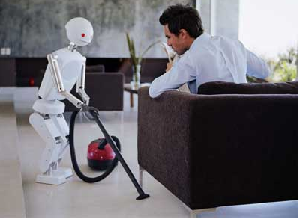
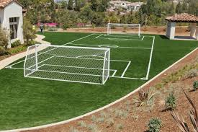
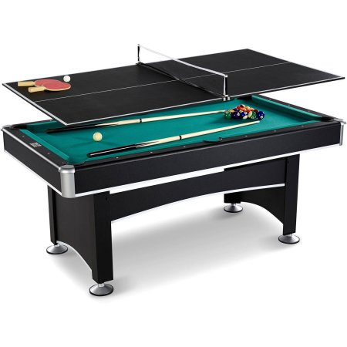
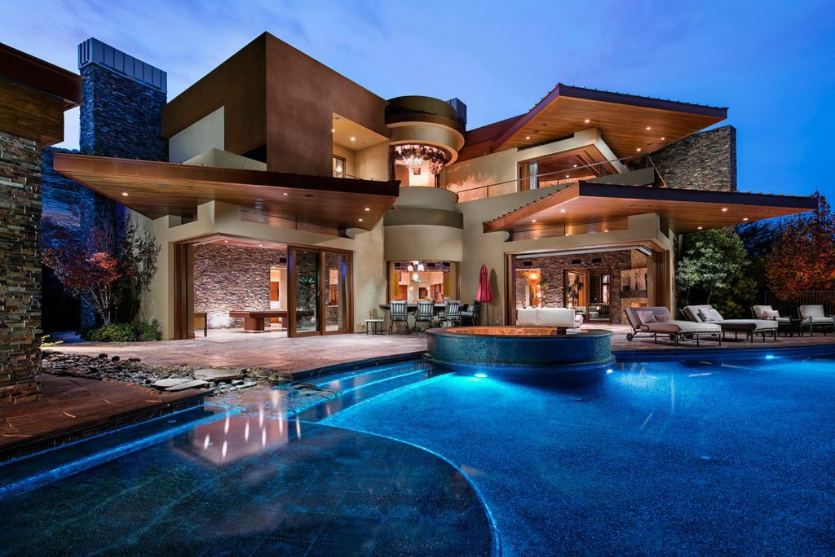
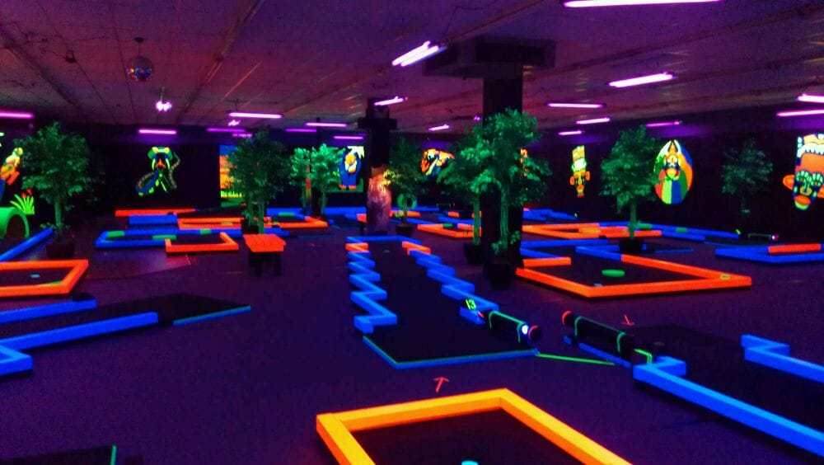
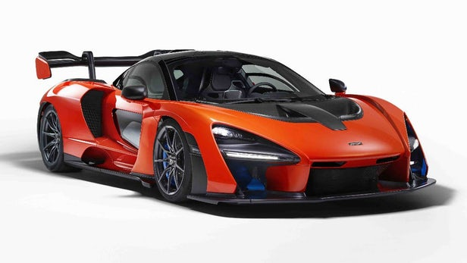
A typical day for me will look like waking up and eating with my family which is my wife and 2 kids. I will then go out and play soccer for a little bit before it gets really hot, then go for a dip in the pool. I will then play games with my son on the xbox playing whatever game we want, then maybe practice my putting on the course. Next I will probably go out with my friends or wife for lunch in my McLaren. The best part would being able to get any type of drink when I want because my robot servant will bring it to me. I will then have dinner with my family again, then end the day off with a game of pool or ping pong. All the while having fun with my pets.

My Career’s annual income would be $46,000 to $90,000 so a decent amount.

My wedding would be classic on the beach which would cost around $10,000-$15,000
My 2 children would cost around $233,610 from birth to 17 years old.
My car will cost $400,000
The house will cost around $3,000,000 in Coquitlam
The mini golf course would cost around $100,000
The cat would cost around $1,500 after food and everything.
The wiener dog would cost around $1,500
The German Shepard also costs around $1,500
The ping pong/ pool table would cost $1,000
The field would be around $30,000
The robot does not have a price yet but is really expensive obviously
The gaming setup would cost around $1,500

