Float Your Boat Challenge
By: (First & Last Name)
Group Members:
Science 10 Block __

Problem:

Hypothesis: Use an “If… (independent variable) then… (dependent variable) because” statement.
If the base of the boat is big in surface area, then the boat will hold the greatest quantity of pennies because it’s big enough to hold a lot of pennies.

Observations:
Insert 3 pictures of the boat design and label them
- Top view
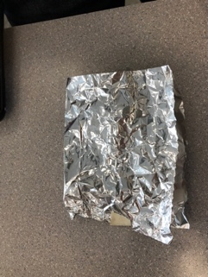
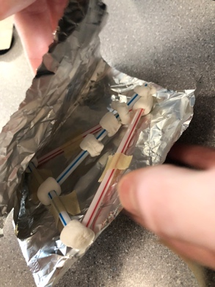
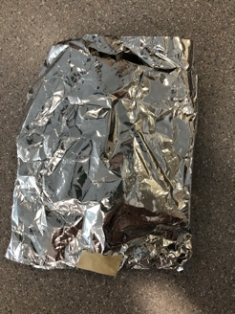
- Bottom view
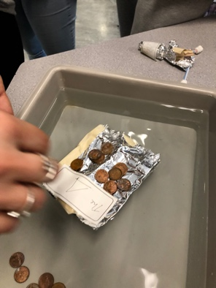
- Picture during the challenge

Results and Conclusions:
The boat held…
20 pennies
The original thinking and reasoning behind the design was…

We tried to make a triangle because it is the strongest shape. While we still did we hid it under the tinfoil.

If the following challenge was repeated, to improve the boat design, the following changes would be made….because….

Bring up the sides so no water could get in and so we could hold more pennies.

Upload this document to your Edublog and Tag your post “floatyourboatdurandsc10blk_” add your block letter “C or D”

