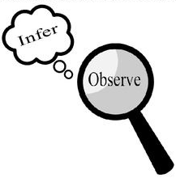
Observations and Inferences
Science 10 Name: Carson BLK: C/4

OBJECT | OBSERVATIONS  Words that describe the object | INFERENCES  Ie: Where might the object come from? Possible uses? Etc. | QUESTIONS YOU HAVE ABOUT THE OBJECT
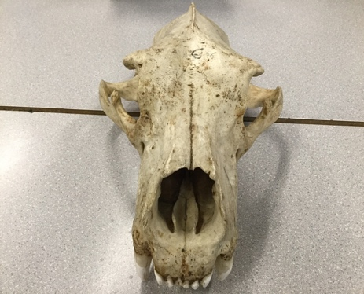 | - Dusty  - Long two teeth  - Big head and nose  - Old  - Jaw that sticks out on each side  - Long head | - It could come from a K9  - Maybe a tiger  - It’s teeth are for hunting and killing  - It’s big nose is for sniffing out prey | - Why such big jaws.  - What animal is it for  - Why is one of his/her teeth chipped  - Where’s its bottom jaw  - Is this animal living or extinct  - What animals did it hunt
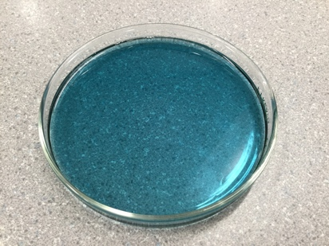 | - Translucent  - Blue  - Liquid  - Thick  - Smells like detergent  - Moves slowly | - Probably a laundry detergent  - Use to wash clothes  - Not supposed to be drank  - Made of chemicals  - Poisonous | - What brand is it  - What gives it its soapy smell  - Why is it blue  - What chemicals are in it
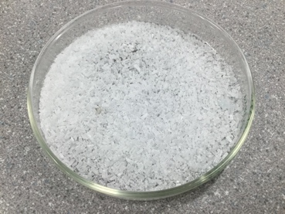 | - White crystal texture  - Small pieces  - Translucent until bunched  - It’s a solid  - Light | - Salt before grained  - Easy to obtain  - Crystals  - It’s a type of mineral | - Is it edible  - Is it buyable  - Is it salt  - Is it quartz  - Why is it white
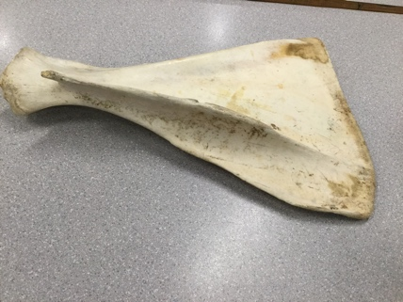 | - Flat on one side, curved on the other  - It has a part sticking out  - White/pale  - Has a red mark  - Dirty  - Dry  - It’s a Bone | - Broken off  - Old  - Belonged to a big animal  - Looks like a fin from an aquatic animal | - What animal is it from  - How old was it  - What is this bone used for  - Why does it have a red mark

Observations/Inferences Assignment Assessment
Name: _____________________
Ex: Excellent VG: Very Good G: Good S: Satisfactory IN: Improvement is needed
Criteria | IN | S | G | VG | Ex
The following is included
- All 4 Images included
Observations:
- A minimum of 5 detailed observations made
Inferences:
- Thoughtful and logical inferences made
Questions:
- 2 thoughtful and logical questions made
- Spelling/grammar
- Assignment was completed on time
/10

