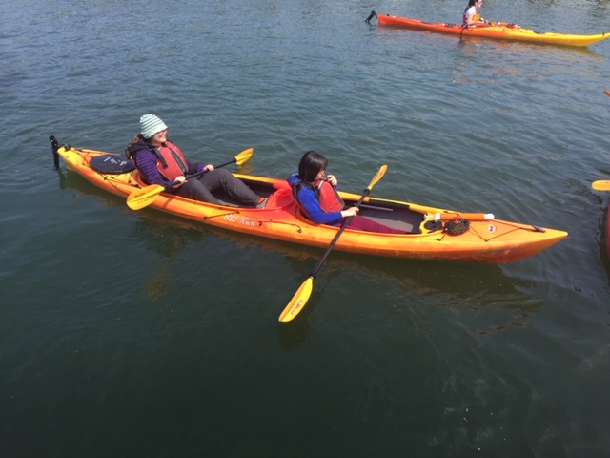

My Kayaking Experience
On a windy, bright afternoon in the month of May, my grade 8 class and another grade 8 class went kayaking. My friend, Jessica McIntosh and I were glowing with excitement. The sun was shining on my face as Jessica and I kayaked. We were mostly at the back of the class because of our slowness. As the water rippled around us, we tried to paddle us fast as lightning but were as slow as turtles. However, the instructor stayed beside us as we paddled in the back of the class. They showed us furry otters as they were getting out in the sunny, beautiful day to sunbathe. As they were lying down, we got a quick glance at them and the instructor started talking about how the otters were sunbathing in the bright sunny day to get out of the water for a little while to breathe some fresh air. I felt the strength of the water pushing us the other way while we were paddling and the wind in our face as we did the paddling in the water, which felt refreshing. At first, we felt strong and full of energy, but then after a while we felt weak and tired in our arms. We continued paddling with our sore, weak arms to the two other instructors.
I remember when we had to jump from one kayak to another for fun without falling. While my friend felt cautious and stressed doing it, I felt excited in looking at people prancing over the glistening, pure water underneath them as they fell in the cold, icy water with their rough and hard, puffy life jackets. The splash of the water went in the air as they fell in the water and the tiny droplets rained down on to everyone including me. I watched people, one after another, try to jump onto the shaky, hard kayaks, then failing and falling into the water. I remember the laughs and joy of the people falling into the water and then floating back up. When the waves rocked all the kayaks, the feeling of almost falling off the kayak, made me think I would fall into the cold, icy water.
Continuing down and on our way back to the dock in the sunny, bright day with the cold and icy water by our side and the wind blowing around me, made the kayaking trip feel awesome. Near the end, I remember the icy cold water splashing on to me when people started shooting us with their little water shooters and the fun I had when I tried to do it back but had to pump up the water first. As my friend paddled us, I tried to squirt the cold, not so clear water into their face. I imagined the water would squirt far like an arch in the sky but squirted the tiniest droplets of water into the cold lake. I was soaking wet by the end from all the people who squirted me with the lake’s chilly water. As we kayaked back, we tried in vain to shoot the water at the guys who squirted us. This was my second time kayaking at the same place in Rocky Point and was a great experience for me.

