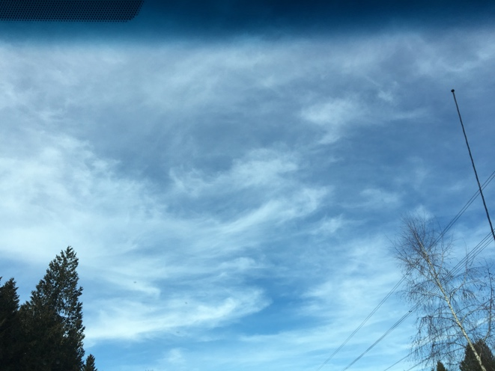

September 8

6:03 am

Cumulus

This is a cumulus cloud because it has a flat bottom and it looks like it is a cotton ball and fluffy.

March 13

11:30 pm

Nimbostratus

This is a nimbostratus a type of cloud forming a thick gray layer, which rain or snow often falls.

March 12

3:19 pm

Stratus

It is a stratus because it is flat and hazy the colours are from dark gray to nearly white.

September 8

1:02 pm

Cirrostratus

It is a cirrostratus because it is very thin and usually forms into halos.