
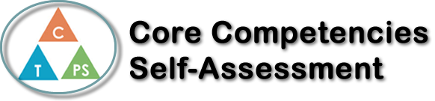
Name: Brent | Date: November 29, 2022

  How does the artifact you selected demonstrate strengths & growth in the communication competency?  In what ways might you further develop your communication competency? | Self-Reflection  Describe how the artifact you selected shows your strengths & growth in specific core competencies. The prompt questions on the left - or other self-assessment activities you may have done - may guide your reflection process.  I am an active listener and can respond to simple, direct questions.  As the editor of the video in the PowerPoint. I was responsible for editing the video alone, but I was aware that I was in a group project. So, I made sure to listen and to ask group members what their vision of the video will look like and make a video that satisfies everyone’s needs.  I can present information clearly and in an organized way.  Because of my experience as a video editor before, I had made sure to present and highlight the most important points in the video whilst keeping flow and maintaining the immersion of the video.  I can recount simple experiences and activities and tell something I learned.    This experience was something to remember and very different from the things I do in my life. From my research, editing and social interaction, I have learned a lot about my community and how to help. But I’ve also learnt how to work as a team and utilize my skills to achieve the best product together.  I commit to taking the following actions for the benefit of my community: I am going to start donating things I do not need to those who need it more than I do. I want to volunteer and help out at any youth homeless shelters and try to make a homeless person feel a bit safer and more welcome. In the future, I hope I will find more opportunities to utilize my editing skills and touch on the youth homeless area.

X

How does the artifact you selected demonstrate strengths & growth in the thinking competencies?

In what ways might you further develop your thinking competencies?


How does the artifact you selected demonstrate strengths & growth in the personal & social competencies?

In what ways might you further develop your personal & social competencies?

Publish Your Self Assessment
You will now attach and/or embed your self-assessment to the bottom of the blog post with the artifact you have chosen. You may choose to make this post private or public. After placing your artifact on a blog post, follow the instructions below.
- Categories - Self-Assessment
- Tags - Now tag your post using the tag that corresponds to the competency that you have written about. You can choose more than one. Please use lower case letters and be exact.
  - #creativethinkingcc
  - #communicationcc
  - #criticalthinkingcc
  - #socialresponsibilitycc
  - #personalidentitycc
  - #personalawarenesscc
- Use the Add Document button located at the top of your post page and embed your self-assessment at the bottom of your blog post.
- Publish

