- Fire (i.e. what to do if one happens)
- If it is small, try putting it out with a fire extinguisher
- If it is bigger, call 911 and evacuate the building

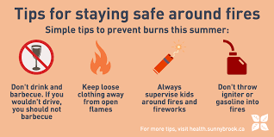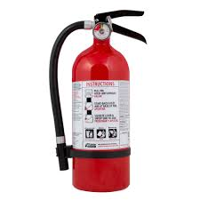
- Burns/Scalds (i.e. how to treat)
- Immediately place the burned skin under cold water
- Apply Polysporin to the wound
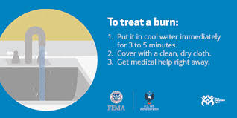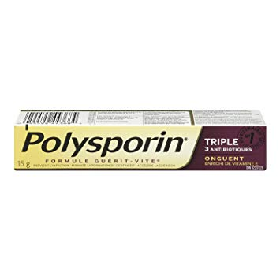
- Chemicals
- Pay attention to warning labels
- Waft to smell, don’t sniff
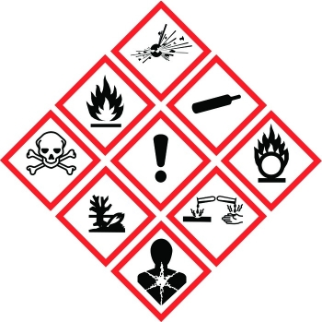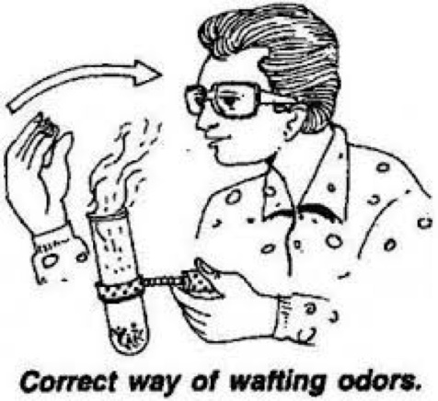
- Slips/Trips/Falls (i.e. how to prevent)
- Wear proper shoes with closed toes
- Use a wet floor sign if there’s a spill
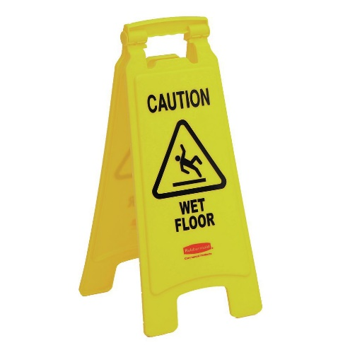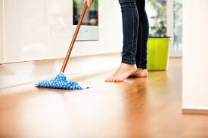
- Cuts (i.e. how to prevent/how to treat)
- Clean the wound and put on a band-aid
- Never place your fingers near the sharp edge of a knife
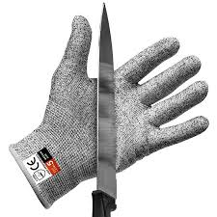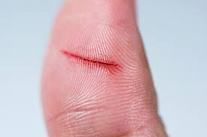
- Heavy Lifting (i.e. of a bag of flour)
- Lift with your legs vs. depending on your arms, because you can hurt your back
- Ask a friend for help if the load is too heavy
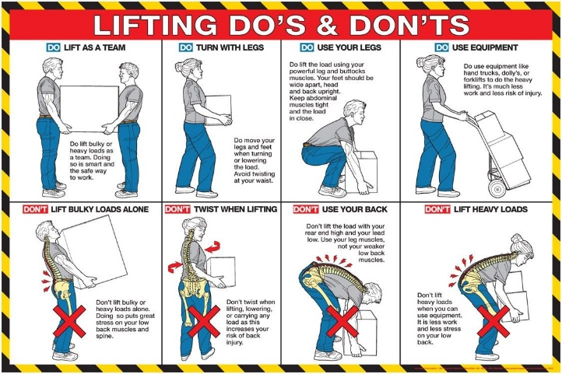
- How to Prevent Food Poisoning
- Avoid raw and undercooked or improperly prepared foods
- Don’t use the same surface for fruits/veggies and meat

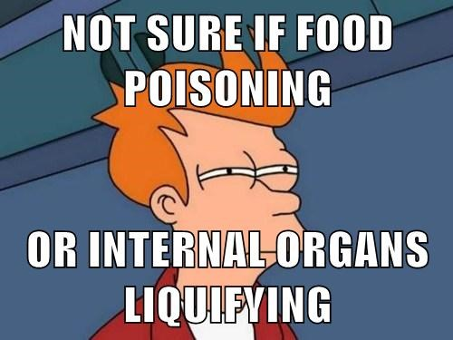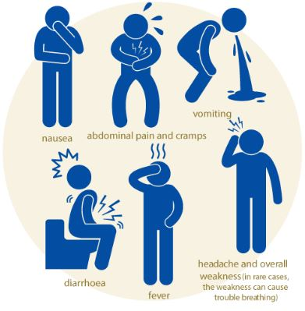
- Waste Management
- Put food scraps in the compost bin
- Paper and glass go in the recycling
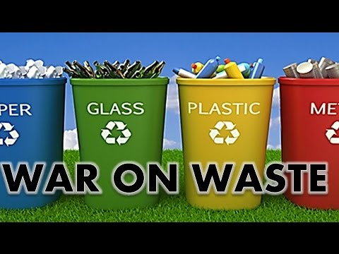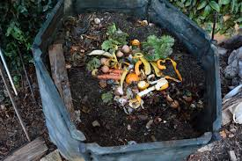
- Personal Hygiene
- Wash your hands with soap and warm water
- Keep long hair away from food
