The Closest Chimp to Mankind
By Branden Park
October 13th, 2020

Sly, the most intelligent chimp in the world had caused minor problems in the process of the experiment, but after people have been to his cage his actions have come more radical. People think that it is because of the implant chip that the scientists put in his head and has made him more violent then he was.

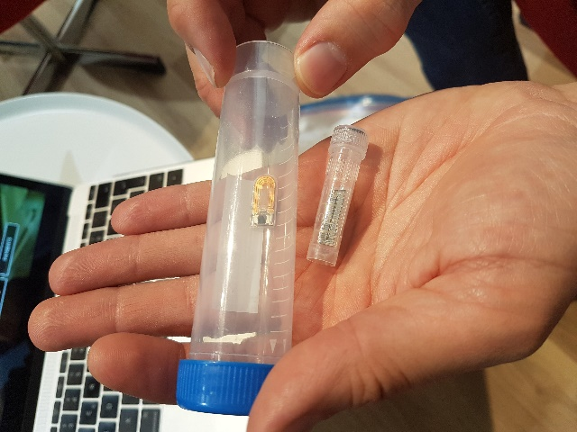
Intelligence Increased by Robotic Chip
The chip that is inside of his head helps him think quicker and smarter like an IQ Amplifier, which makes him think more like humans. After the chip has been inserted in his brain he started to interact with people, learn how to read, talk and can potter vases which is impressive for a chimp but the problem is the smarter he gets he becomes more violent.

Anger Issues by Sly
Sly had been continuously having anger issues like throwing the clay, writing inappropriate words, talking, and screaming furiously, one-time students where mocking and slamming the cage glass well that was not a good idea for that motion Sly had throw clay at them and wrote “SSA” backwards and expressed that he was angry. because of that, Sly had his pottery taken away by the chief director of the experiment. Delilah, which was the supervisor for the experiment said, “Sly had been in a great process with working on his speech and writing abilities but, he still has the animal instincts in his body and cannot handle his emotions properly such as, when we track his brain system he wants to kill or hurt the object if it distracts or makes him angry, we know he is in a odd position that is in between a human and a chimp, so our future plan is to try to make Sly learn to handle emotions and think more humanistic .”

Sly’s Best Friend

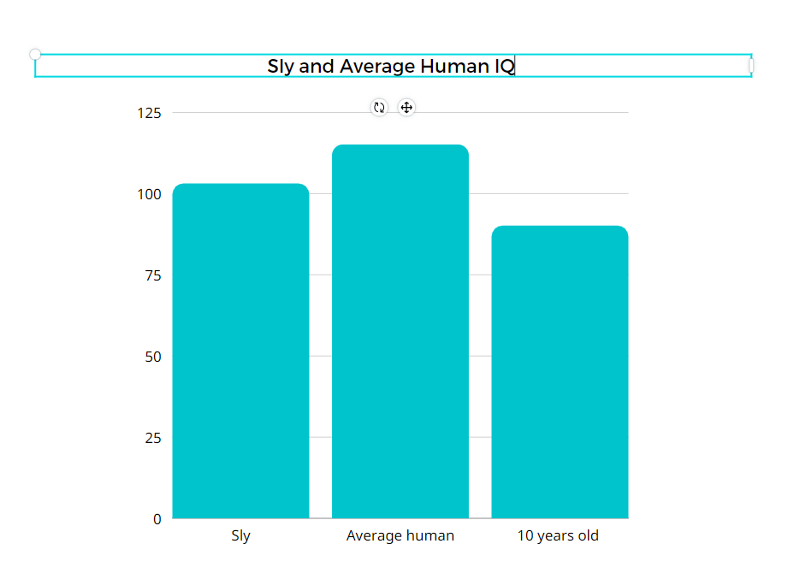
When Sly was first brought to the experiment an employee named Vern helped him to be stability and made him comfortable. He taught talking skills which makes them easy to be friends. Vern was the one to bring pottery to Sly which have changed Sly’s lifestyle to doing nothing to doing pottery. Vern thinks that Sly is having to be treated more like humans, eventually that is not going to happen yet since he has shown motions of animals, he is more likely to be seem an chimp.

What Will They Do About Sly?
Although Sly is a chimp that has a human brain scientist are thinking of what do to in the future. The options are in below.
- Keep on experimenting in the lab
- Going back to the wild
- Moving to the zoo
- Getting adopt by people

As you see above some options are not possible at the point like getting adopt by peoples is dangerous and going back to the wild will not be easy to fit since he has human level brain system, but most experts and scientist are thinking of asking Sly what do he want to do in the future since he can think and talk about his thoughts.

https://youtu.be/FC1oh55goSc < A video to learn more about Chimpanzees

