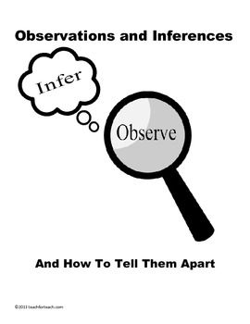**Observations and Inferences**

Science 10 Name: Brad Lee BLK: C

|  |  |  |  |
| --- | --- | --- | --- |
| **OBJECT** | **OBSERVATIONS**  **Words that describe the object** | **INFERENCES**  **Ie: Where might the object come from? Possible uses? Etc.** | **QUESTIONS YOU HAVE ABOUT THE OBJECT** |
| cid:6de1e141-8208-4eec-ba89-f56eb2776cee@CANPRD01.PROD.OUTLOOK.COM | Fleshy, Aged, Slimy, Disgusting | It’s an eye ball.  They’ve been aged for a long period of time. | What animal did I come from?  How long has this been aged? |
|  | Keychain, utility, red, | it’s a utility tool.  this maybe used as a tool when going hiking or fishing. | What uses does this have?  How can I use this?  Can I find this at my local super market? |
|  | Crystal, powder-like, soap smell, white/transparent. | It’s a crystal-like substance  Some are transparent, others are white  It has a powdery like texture | What can this be used for?  Is it poisonous?  Is it used in your everyday life? |
|  | Bone, Skull, fossilized, aged, | This is skull of an animal.  This animal must’ve been a carnivore due to the sharp canine teeth. | How old is this fossil?  Is this species extinct?  Can this animal be found today?  Where did archeologists find this? |

|  |  |  |  |  |  |
| --- | --- | --- | --- | --- | --- |
| **Observations/Inferences Assignment Assessment**  Name: Brad Lee  **Ex: Excellent VG: Very Good G: Good S: Satisfactory IN: Improvement is needed** | | | | | |
| **Criteria** | **IN** | **S** | **G** | **VG** | **Ex** |
| The following is included   * All 4 Images included |  |  | | | **X** |
| Observations:   * A minimum of 5 **detailed** observations made |  |  | **X** |  |  |
| Inferences:   * **Thoughtful and logical** inferences made |  |  | **X** |  |  |
| Questions:   * 2 thoughtful and logical questions made |  |  |  | **X** |  |
| * Spelling/grammar |  |  |  | **X** |  |
| * Assignment was completed on time |  |  | | | **X** |

/10