Float Your Boat Challenge
By: Brad Lee
Group Members: Scott, Anton
Science 10 Block C

Problem: How can I make a boat, so it can carry the most pennies?

Hypothesis: If I make the boat walls higher and make the base more sturdy, then the boat will be able to hold more pennies, because when the pennies weighs down the boat it’ll take longer for the boat to sink.

Observations:
Insert 3 pictures of the boat design and label them
- Top View 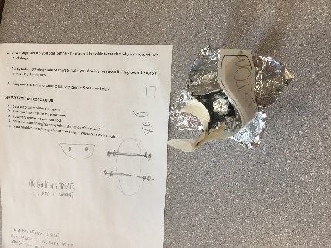
- Bottom view 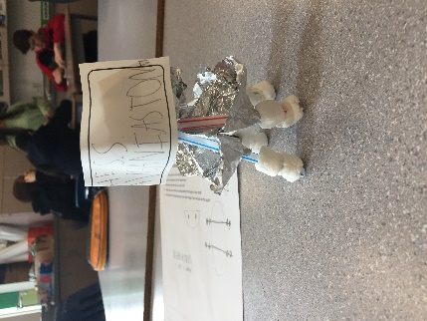
- Picture during the challenge 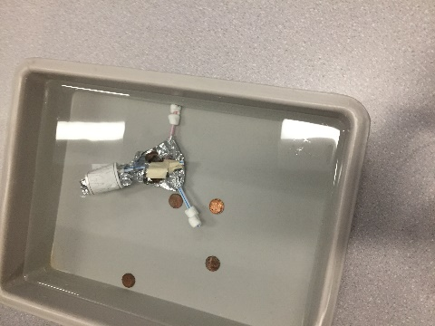

Results and Conclusions:
The boat held 6 pennies

The original thinking and reasoning behind the design was Because we had no real design when discussing on the boat.

If the following challenge was repeated, to improve the boat design, the following changes would be To make an actual design and go along with that design because during the time given to build this, we didn’t have a final design.

Upload this document to your Edublog and Tag your post “floatyourboatdurandsc10blk_” add your block letter “C or D”

