Documents: Why did the Rebellion of 1837 fail?

# ****Life and adventures of Col. L.A. Norton**** written by himself

#### Published ****1887****

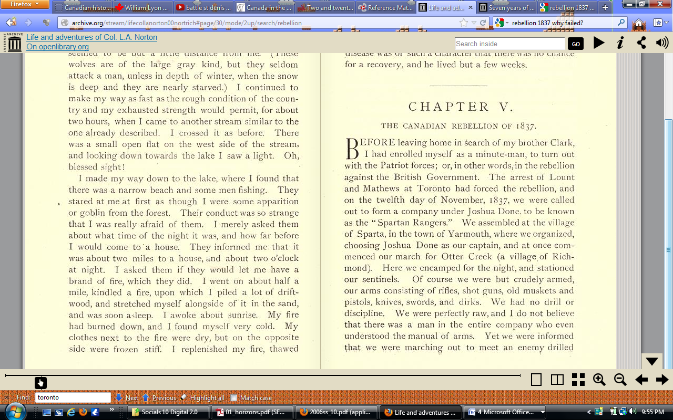 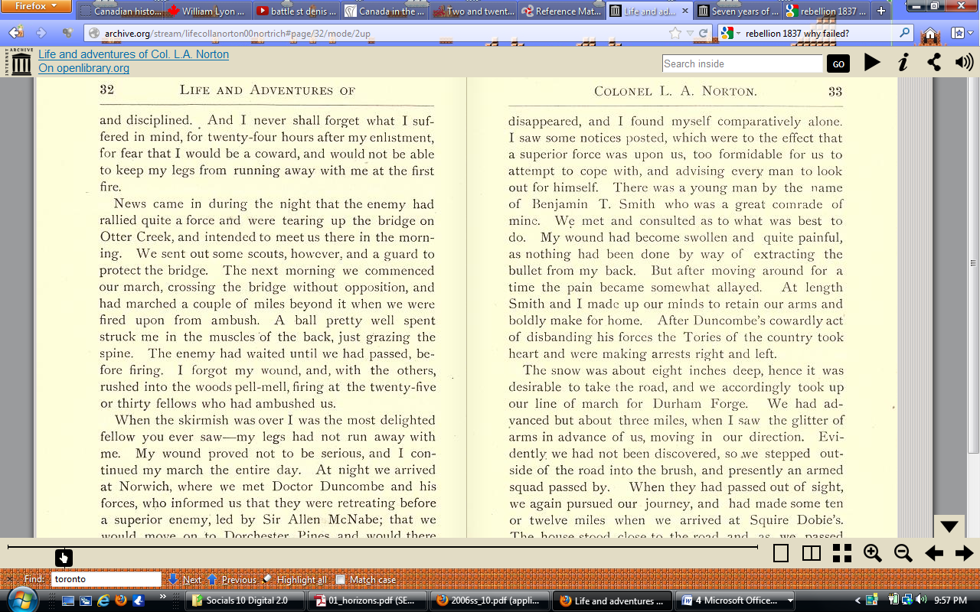<http://openlibrary.org/books/OL7210596M/Life_and_adventures_of_Col._L.A._Norton>

# ****Mackenzie's own narrative of the late rebellion**** with illustrations and notes, critical and explanatory: exhibiting the only true account of what took place at the memorable siege of Toronto, in the month of December, 1837

#### Published ****1838****

<http://openlibrary.org/books/OL24351584M/Mackenzie%27s_own_narrative_of_the_late_rebellion>

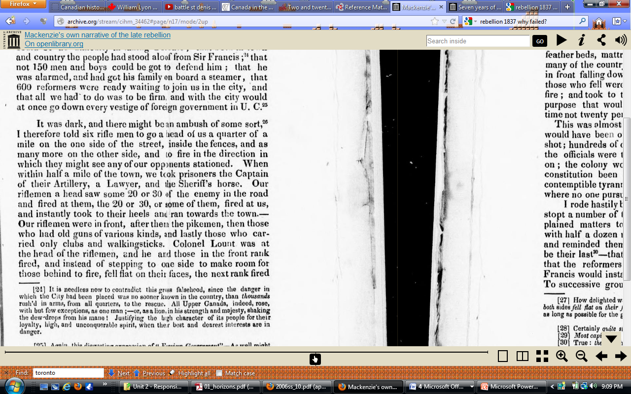

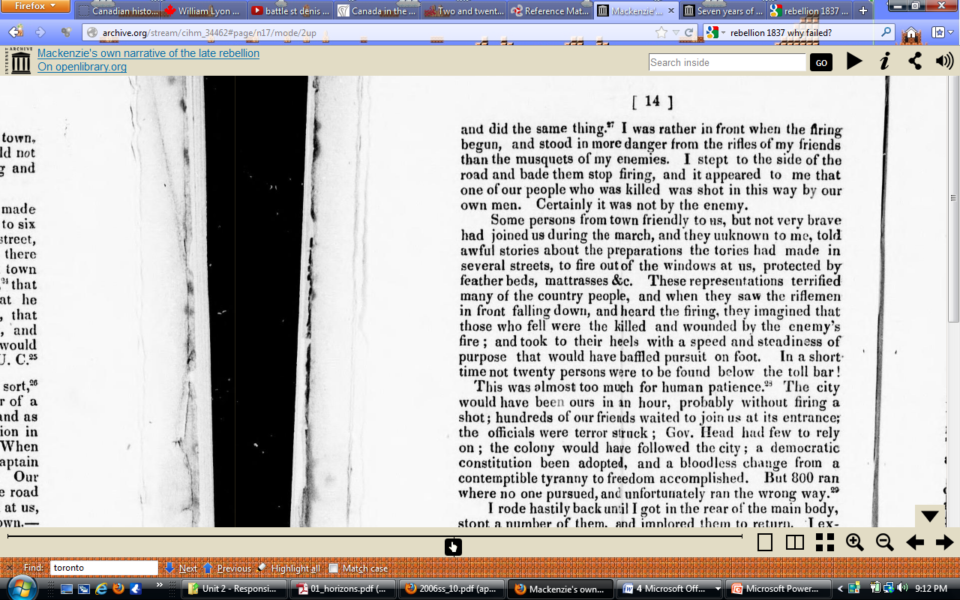

# ****Some personal recollections of the Rebellion of 1837 in Canada**** by Sydney Bellingham ...

#### Published ****1901****

(on the side of the British at St Charles)

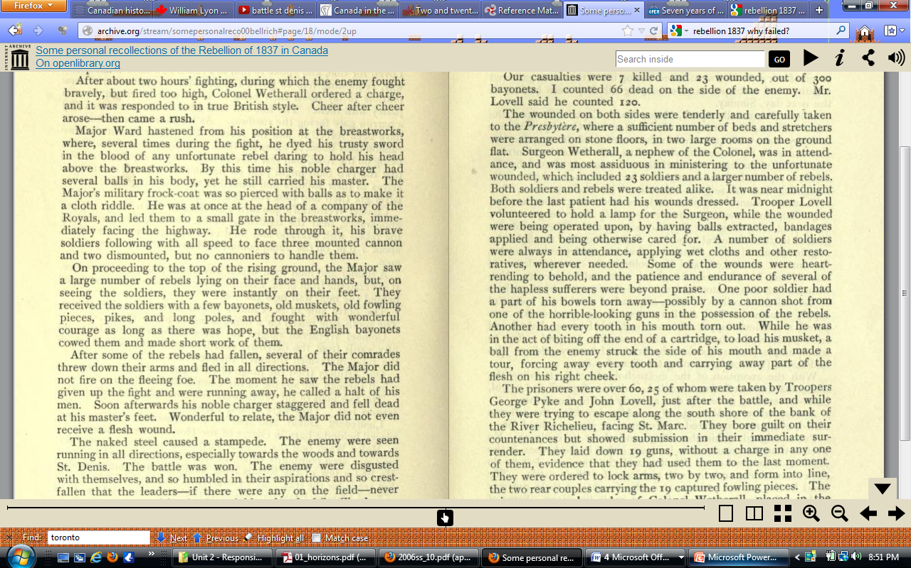<http://openlibrary.org/books/OL14042653M/Some_personal_recollections_of_the_Rebellion_of_1837_in_Canada>

**Seven years of my life, or, Narrative of a patriot exile**

# by Robert Marsh

#### Published ****1848****

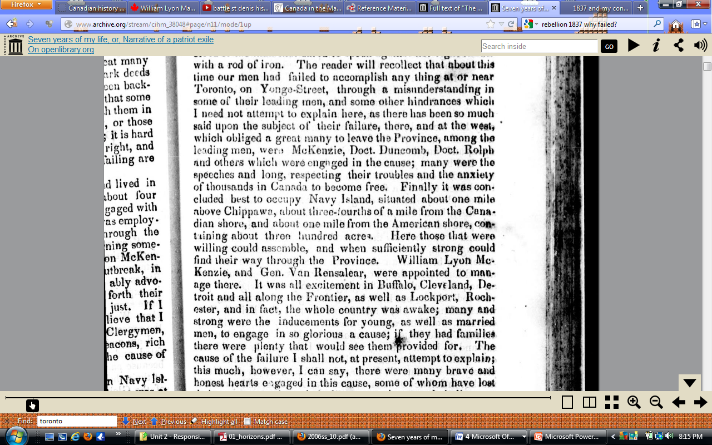<http://openlibrary.org/books/OL24444556M/Seven_years_of_my_life_or_Narrative_of_a_patriot_exile>

[**Thomas Storrow Brown**](http://english.republiquelibre.org/Thomas_Storrow_Brown)

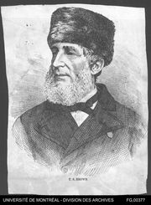

April 1898  
  
Quebec City, Raoul Renault, Publisher  
(originally published in the *New Dominion Monthly* in April 1869)

It may well be asked what we expected to effect with such wretched preparations at St. Charles? I can only answer for myself, that, seeing the determined animation of the people, I thought the leaders would remain with them, and the raising of the "Patriot" flag at St. Charles, would be the signal for a general rising; that men and arms would flow in from the States, as into [Texas](http://en.wikipedia.org/wiki/Texas); and that Sir John Colborne would evacuate Montreal for Quebec, leaving us all the country outside. Had there been the militia laws and military knowledge of to-day, this was easy. Then I thought we would in the winter send Commissioners to England, in mercantile phrase, "to make a settlement". Ours was simply a provincial war of factions. The "Bureaucrats" vanquished us, and the province had to wait a few years for a government based upon "the well-understood wishes of the people." Had we vanquished them, there would have been only a delay of a few months, with an immense saving to the British Government.

<http://english.republiquelibre.org/1837_and_my_connection_with_it>