Canada Expands West Political Cartoon Organizer
Part 1:
- Complete the following chart for the Battle of Seven Oaks:
Causes | Components | Consequences

- Both of the following images were created by C.W. Jefferys ca. 1945, there are subtle differences between the two. What are the differences between the drawing and the painting?
As depicted in the drawing | As depicted in the painting

How do the differences create different perspective between the images?

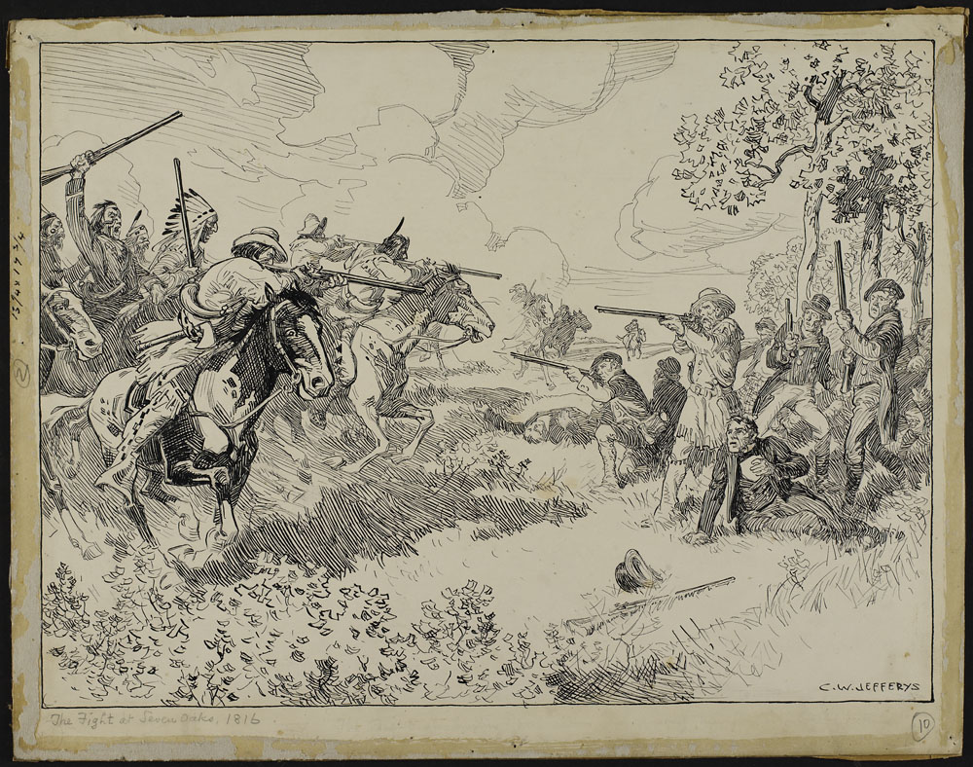
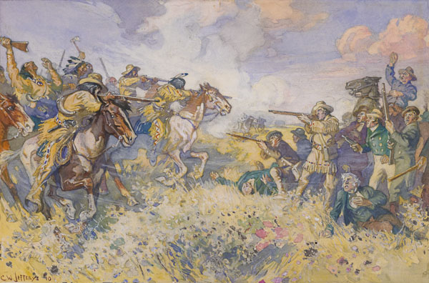

- There could be 3 different perspectives of the Battle of Seven Oaks, provide a sketch of the other two perspectives not accounted for in the C.W. Jefferys works above. (you can hand sketch them, then take a picture and insert it into this document)
Insert images here

Part 2:
Read Horizons – Chapter 4 - pages 152-155
- Find as many points as you can to support the ownership of either side (you may even want to look at previous sections of the textbook):
Belongs to the Metis | Belongs to the HBC/Britain/Canada

- Of the two parties above, who has a better claim to the land? Explain why one side does and refute the arguments of the other side.

- Create an analogy that highlights your explanation in #2:

Part 3:
- Define and state the significance of each of the following (Horizons – Chapter 4 – pages 156-160):
Term | Definition/Background | Significance
Rupert’s Land
Louis Riel
Land surveyors
Canada Party (page 155)
Fort Garry
William McDougall
John Schultz
Thomas Scott
John A MacDonald

- Sketch a caricature of the following historical figures from the Red River Rebellion and depict them as either good or bad based on their actions. Briefly explain the reasons why you would depict them this way:
Louis Riel
Sketch:  Insert image here | Explanation:

John Schultz
Sketch:  Insert image here | Explanation:

Thomas Scott
Sketch:  Insert image here | Explanation:

John A MacDonald
Sketch:  Insert image here | Explanation:

Part 4:
- List the articles from the Manitoba Act that match what the Metis were asking for in the Metis List of Rights:
Article #: | Translation:

- Based on your findings in #1 above, would the Metis be satisfied with the Manitoba Act? Explain why or why not (think about quality and quantity of rights given):

- What is scrip? How was the process of attaining scrip made difficult? (Horizons – Chapter 5 – pages 167-168 and Collections Canada)

- What were the Laws of St Laurent? What happened to these laws and how was Lawrence Clarke involved? (Horizons – Chapter 5 – pages 169-172)

- How would you characterize Canada’s treatment of the Metis after the Red River Rebellion (explain by considering the Manitoba Act, and what happened with scrip and the Laws of St Laurent)?

- Sketch a fictitious scene that illustrates #5 above (what could each character or concept be symbolized as?).
Provide sketch here

Part 5:
- Explain why whiskey was a growing problem for First Nations people in the Plains. (CBC.ca)

- What are the reasons for the creation of the Northwest Mounted Police? (Horizons – Chapter 5 – pages 174-175)

- Sketch 3 different book covers for the Whiskey Peddler based on 3 different perspectives: Aboriginals, Americans, Canadians:
Provide sketches here

Part 6:
- What are the reasons for the Aboriginals and Canada to enter into treaty negotiations?
Aboriginal Reasons | Canada’s Reasons

- What did the Aboriginals receive in Treaties 1-7 in exchange for giving up their rights to the land?

- Make a questionnaire/poll with 3 questions about fairness that are analogies of the Aboriginal’s situation and the treaty agreements. You should not mention treaties or Aboriginals at all.
Provide your questions and explain the analogy’s connection to the Aboriginal situation with treaties:
Questions: | Explain the Analogy:

Part 7:
- View the political cartoons in the image gallery and complete the following:
Title | Describe | Document | Interpret

Part 8:
- Why did MacDonald develop the National Policy? (Horizons – Chapter 5 – pg 197)

- Define each of the three parts of the National policy. For each case, state why MacDonald thought it would benefit Canada:
 | Definition & how to get it done | Benefits
Impose High Tariffs
Settle the West
Build a Transcontinental Railway

- What problems did the construction of the CPR encounter? How were these problems solved? (Route change? William Van Horne? Budget 1883?) (Horizons – Chapter 5 – 198-201)

- Pick one of the following children’s stories to create an analogy for John A Macdonald’s National Policy. Sketch the analogy and explain what parts of your sketch represent the different parts of the John A MacDonald’s National Policy.
  - Three Little Pigs
  - Little Red Riding Hood
  - Jack and the Bean Stalk
  - Goldilocks and the Three Bears
Provide explanation here

Provide sketch here
Part 9:
- Read about the Northwest Rebellion here (http://www.thecanadianencyclopedia.ca/en/article/north-west-rebellion/). What were the causes of the Northwest Rebellion?
Aboriginals | Metis

- Using the same article from above, complete the following:
Historical Figure | Role in the Northwest Rebellion | What happened to them after the Northwest Rebellion?
Gabriel Dumont
Big Bear
Poundmaker
Louis Riel

- Why do you think Canada’s response to the Metis was different during the Red River Rebellion and the Northwest Rebellion?

- Analyze the following painting of the Battle of Fish Creek by comparing it to the written description:
Question | Response
How did the Battle of Fish Creek start
How does the painting reveal the start of battle?
How many soldiers did the Canadians and Metis have at this battle?
Does the painting show the number of soldiers correctly? How do you know?
Who won the battle?
Who looks like they’re winning in the painting? How do you know?
Who’s perspective does this painting show? How do you know?

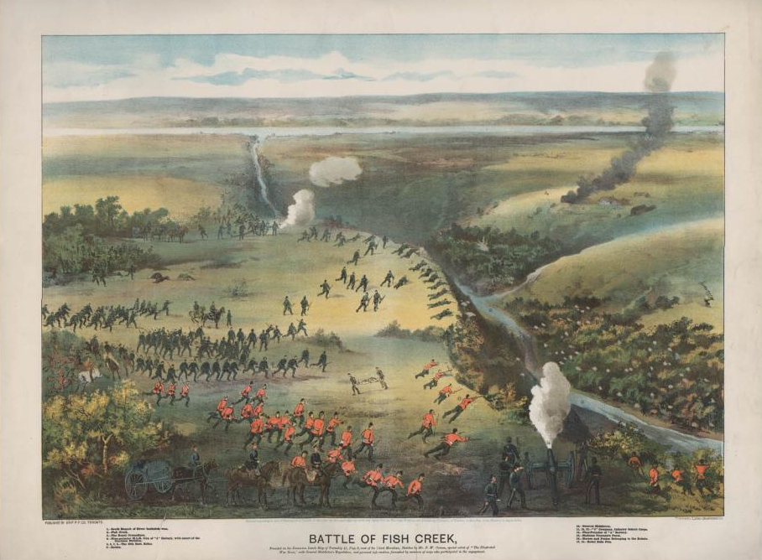
- Create a sketch of the above painting from the opposing perspective:
Insert sketch here

Video Discussion
- Which of the following factor affects ownership of land more: who was there first, who originated there, or who made use of the land? Explain with examples from the past and present.
- Choose one of your analogy questions from Part 6 above, explain the analogy you were creating and explain what the results of your questionnaire says about the fairness of the treaties. Explain whether or not you agree with the questionnaire results.
- Is Canada guilty of genocide when it implemented the Residential School program with Aboriginals? Refer to the definition of genocide provided by the UN.
- Are the names “Red River Rebellion” and “Northwest Rebellion” proper labels for these two events? Explain why or why not. If not, explain what a better label would be.

Cartoon Planning:
- How would you characterize Canada’s treatment of the Aboriginals and the Metis between 1867 and 1885? Come up with an analogy for your characterization – “Canada’s treatment of the Aboriginals and the Metis is like ___(what situation?)___________________”
In your analogy:
- How would John A MacDonald be depicted? Is there an appropriate symbol that could represent him and fit your analogy above?
  - Summarize what MacDonald did in the Red River Rebellion in one statement. How can that fit your analogy?
  - Summarize MacDonald’s intentions with the Treaties and Residential Schools in one statement. How can that fit your analogy?
  - How could the National Policy fit the analogy?
  - Summarize MacDonald’s response in the Northwest Rebellion in one statement. How can that fit your analogy?
- How would the Metis be depicted in your analogy? Is there an appropriate symbol that could represent them?
- How would the Aboriginals be depicted in your analogy? Is there an appropriate symbol that could represent them?
*If you get stuck on one of the steps above, you may have to restart your analogy idea.

- SKETCH your political cartoon. Find someone to explain your sketch to.

- Redo your sketch if necessary.

