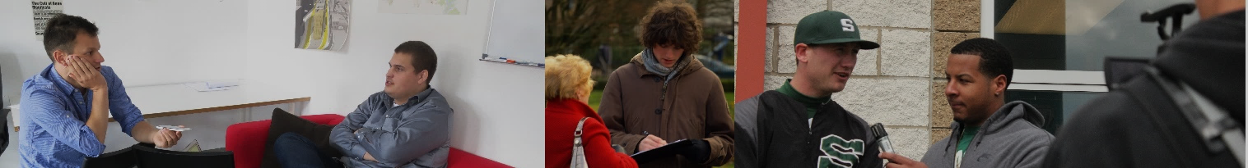
An important skill in the 21st Century is making connections with others. Connections lead to friendships, jobs, opportunities. They open the door for collaboration and cultivation of relationships. The goal of this assignment is for you to find someone who is involved in something that you care about and interview them. You will share your take-aways from the interview on your Edublog.
Community Connection
Instructions
“Assignment Description Video”
Scan QR code above or click below link
https://bit.ly/rsideCCvid
- Choose someone who is involved with something that you are passionate about. This could be a job, a volunteer role, a skill, or a hobby.
- Connect with this individual and plan a time when you can interview them using technology (avoid face to face contact, notify your parents). Options for your interview include, but are not limited to Skype, Facetime, Zoom, Teams, email, DMs through social media platforms, etc.
- Converse with the individual asking them the questions below, as well as your own questions. Either record the responses or document them in written form.
- Create a post on your Edublog account outlining what you learned from the interview and how it connects to you. Your response can be in the form of a video, or a written response (combining pictures and words).
Title: Community Connection
Category: ADL 10 Assignments

Questions
Your own question.

Your own question.

Can you explain your roles and responsibilities with your current position?
What obstacles have you faced to get you where you are today?
What advice would you pass on to someone interested in what you are doing?
Why are you passionate about your job or role?

In your post, it is expected that you mention:
- Who you interviewed including their roles and responsibilities
- Why you chose to interview that individual
- What you learned from the interview and how that connects to your passions/interests
- Media to demonstrate the aspects of the interview with which you connected and feel are important to showcase

Exceeding Expectations:
- Ask your interviewee to read and comment on your post
- Share what opportunities this interview opened up for you.
- Link your post to your interviewees online work; have them link back

Submitting your Assignment:
- When you have completed your Edublog post, please submit the link to your post on TEAMS
Demonstrating Your Learning
Select one of the following formats for your post:

• Written Response on the blog
(answers to the various questions, minimum four pictures, post will include both text and graphics)
OR
• Video Response (1 - 1½ minutes in length)
Other digital tools you may want to use: YouTube, iMovie, Powerpoint, Prezi.

We expect that the tone of this assignment will be considerate and respectful, and use language that is inclusive, appropriate, and appealing to the Riverside community. Your response will be reviewed and if there are concerns or questions with your response you may be contacted by Mr. Barazzuol or Mr. Robinson who are the COL teachers.
* If there is any evidence of plagiarism your response will be considered incomplete and you will have to redo your assignment. If you do not complete an interview before your assigned due date, you will have to complete an alternate assignment for partial marks.

 | Missing (0-6) | Not Meeting (7-9) | Minimal (10-13) | Meeting (14-17) | Exceeding (18-20)
CONNECTION  POST | Missing a connection.  Did not post properly | A connection was attempted but not completed  Minimal information about the interview and individual | A connection was made but it lacked meaning for the student  A retelling of the interview | A connection was made that was meaningful to the student  Effective media; clear description of interviewee and student learning | A connection was made that lead to increased opportunities  Effective media; links to the interviewees work; meaningful reflection.
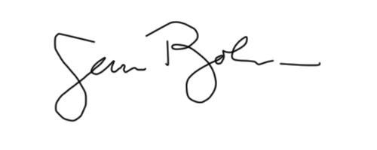
Mr. B. Barazzuol Mr. S. Robinson
bbarazzuol@sd43.bc.ca serobinson@sd43.bc.ca

DUE: Monday, February 13, 2023 (uploaded to your Edublog page and link submitted on Teams).
[photos: Interview (modified) by Arielle Lilley via flickr, “Interviewing“, by Sara Parker, “Interview“, by Alper ÇuğunBy: Alper Çuğun, “ licensed under CC BY-SA 2.0.]

