Digital Footprint
Your goal is to reflect on your digital footprint. You will share how your digital footprint can impact your future education, grad school application, or job and career prospects. With this assignment, we want you to describe the key messages around digital footprints and learn to share with your peers how you will be able to manage your digital footprint responsibly.
Instructions
- Watch the following video about managing your digital footprint. This video is 3 minutes in length. Video: “Your Digital Footprint May Be Unflattering” found at http://www.youtube.com/watch?v=o8C1a2z_cuQ
- Reflect on your own digital footprint. Google yourself. Try to picture how your footprint comes across to others.
- Answer the questions below, share your answers on your Edublogs
- Title: Digital Footprint
- Tag: footprint2019
- Category: Math 9
“Your Digital Footprint May
Be Unflattering” Video
- Engage others with your post and respond to their comments.

Questions
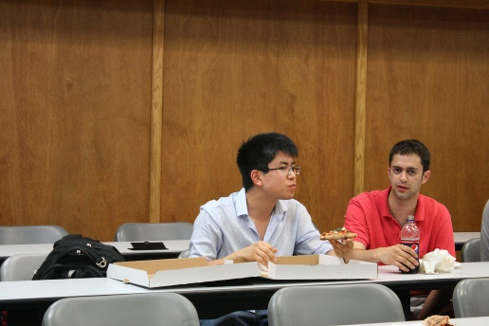
What information did you learn that you would pass on to other students? How would you go about telling them?
Describe at least three strategies that you can use to keep your digital footprint appropriate and safe.
How might your digital footprint affect your future opportunities? Give at least two examples.

Deliverables
Ensure that your response effectively addresses the goals provided above and answers all of the questions listed in the instructions. You have the option of doing the response in one of the formats listed below:
Option 1: Video Response (1 - 1½ minutes in length)
Option 2: Poster/Infographic (one detailed poster, including both text and graphics)
Option 3: Article (answer the three above questions in your own words, include 4 photos minimum taken from Pexels or Google Images>Tools>Labeled for Reuse, also include references or works cited crediting where you took the photos from)
Your response is due ___________Monday, September 23rd, 2019___________ and must be uploaded to your Edublogs account. We expect that the tone of this assignment will be considerate and respectful, and use language that is inclusive, appropriate, and appealing to the Riverside community. Your response will be reviewed and if there are concerns or questions with your response you may be contacted by Mr. Barazzuol or Mr. Robinson who are the COL teachers. If there is any evidence of plagiarism, your response will be considered incomplete and you will have to redo your assignment.

Possible digital tools to use might be: Youtube, iMovie, Sway, Easel.ly, Prezi. O365 PowerPoints can be used but you must sync OneDrive with your computer first to upload it.

See an example video: https://www.youtube.com/watch?v=n9DDzRZaagQ

Feedback will come in the form of an email and a comment on your blog. This assignment will count for 10% of your overall grade in ADL 10. We will use the rubric below:

 | Missing - 0 | Not Meeting – 1-2 | Minimal - 3 | Meeting – 4 | Exceeding - 5
Overall Message and Media  (What is your conclusion and how did you show it?) | Missing. | Message shows no or little understanding of your digital footprint. The media is not apparent as well. | Message shows an understanding of your digital footprint but information was minimal. No media was included in your post. | Message shows a good understanding of your digital footprint. Media works well with your message but the two could complement each other better. | Message clearly demonstrates fully your understanding of your digital footprint; media and message blend together seamlessly.
Analyze (Did you find key information to support your message?) | Missing. | Information given does not support the message that you are trying to present. | Information present but is minimal and does not fully support your message. | Good information present; answers are typical and accurate | Excellent information. All your answers are insightful and shows a personal connection to the activity; pictures/sources  are referenced from share friendly sites.
Audience  (What do other people think about your presentation?) | Missing. | The final product poorly communicates and should not be shared to the outside world. | The final product minimally engages the audience but communication is muddled by incomplete thoughts or poor editing | The final product is received by the audience but does not elicit a further response to be shared with the outside world. | The final product is well received by the audience in the outside world and inspires further discussion as evidenced by commentators.
[photos: Footprints (modified) by Peter Nijenhuis via flickr, “Uni Interview“, by Alex France, “Footprint“, by Nadar, “Ann Miura-Ko“, by HackNY.org licensed under CC BY-SA 2.0.]
B. Barazzuol / S. Robinson

