
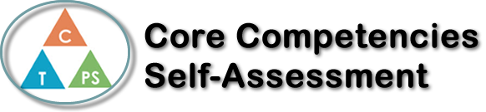
Name: Ayla Williams | Date: November 15, 2022

  How does the artifact you selected demonstrate strengths & growth in the communication competency?  In what ways might you further develop your communication competency? | First assignment communication was talking to clients. We would have to make a sketch, of a front view, a side view, and top view, all while making sure it meets the client’s expectations, and in a good amount of time, making sure not to take long, because a client would be in front of you telling you what they’d like. We’d have to communicate to make sure the sketch was making meets the client’s expectation. Such as length, width etc. I could have asked the client more questions, and double checking with the client in an efficient way.  Figurine assignment grew my thinking skills. It took a lot of effort and time to make sense of how to use the system. There were so many different settings we had to check on, such as the measurements. It had to be a certain measurement, and if it wasn’t we’d have to change it. It grew me in strength because I often struggle to ask for help, and because of how much I was struggling with the assignment, I learned how to grow out of my comfort zone.  I could further develop by just growing my trust, and take notes of the tutorials, so itd be easier on myself.  Figurine assignment helped me deal with my personal emotions more. Even under stress, knowing I could do something that I would be proud of. I could further develop my personal and social skills by being more aware of my emotions, and push to my limit, but don’t go beyond them.


How does the artifact you selected demonstrate strengths & growth in the thinking competencies?

In what ways might you further develop your thinking competencies?


How does the artifact you selected demonstrate strengths & growth in the personal & social competencies?

In what ways might you further develop your personal & social competencies?

Publish Your Self Assessment
You will now attach and/or embed your self-assessment to the bottom of the blog post with the artifact you have chosen. You may choose to make this post private or public. After placing your artifact on a blog post, follow the instructions below.
- Categories - Self-Assessment
- Tags - Now tag your post using the tag that corresponds to the competency that you have written about. You can choose more than one. Please use lower case letters and be exact.
  - #creativethinkingcc
  - #communicationcc
  - #criticalthinkingcc
  - #socialresponsibilitycc
  - #personalidentitycc
  - #personalawarenesscc
- Use the Add Document button located at the top of your post page and embed your self-assessment at the bottom of your blog post.
- Publish

