Field studies,

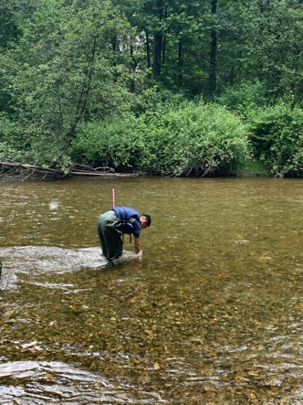
At the Coquitlam river we went to go find living things in the water, and get the temperature of the water and the temperature up stream. We had Eric go in the after and use a butterfly net to catch living things. He would hold it at the bottom of the river and use a brush to wipe the net. We aswell measured the air temperature.
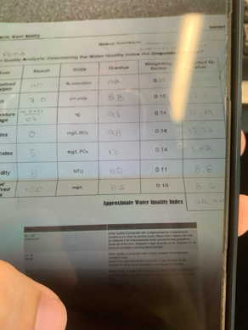
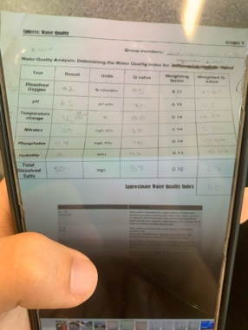
Water temperature Swamp temperature
This ends up connecting us to the 4 spheres because the hydrosphere would be the water and steam itself. And we also took temperature of the atmosphere the air itself. We would have a pepper of the type of living things in the water which connects to biosphere, we would have the paper to get a good example of how healthy the water is depending on the living things that would live in the environment. With all of this, that leaves us to the Geosphere, all the spheres in one.

Coquitlam river site;

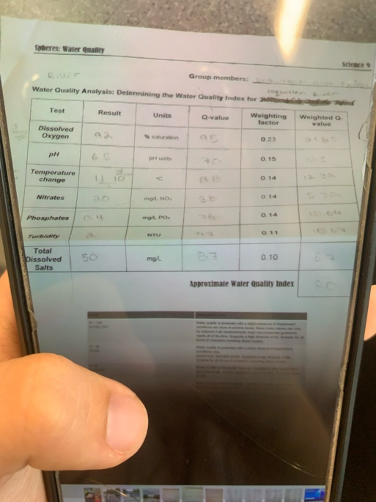
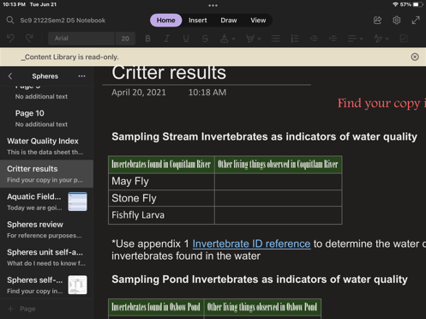
We found 3 different critters in the Coquitlam river. With the results from the critters we have found we have found the Coquitlam river has good-fair water quality.

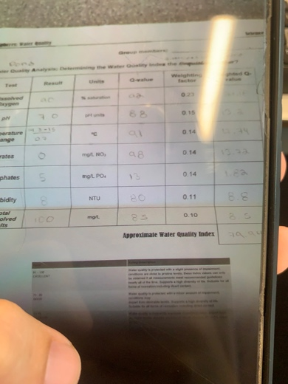
Oxbow pond site;
We. Found the following critters;
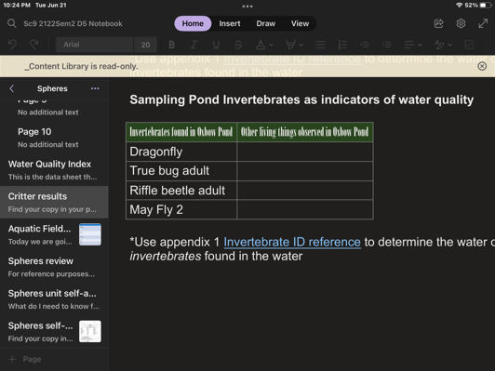
And with these critters we found he pond has a fair water quality.

- For the pond the overall water quality index value was 72.68 which indicated a fairly good water quality. On the other hand for the water quality test the invertebrates showed similar results with a fairly good water quality. Overall these values tell us that the health of the water in the pond is fairly good and can sustain life in it.
- For the river the overall water quality index value was 89.03 which indicated a very good water quality. On the other hand for the water quality test the invertebrates in the water ranged a bit but showed similar results with a fairly good water quality. Overall these values tell us that the health of the water in the river is very good and can sustain diverse life in it.
The similarity to the 2 water qualities was that they wee both good, Coquitlam river was better then the pond, because the pond was a fairly good quality.
I enjoyed he exploring and looking at cool neat things, such as how to measure water quality, and get the temperature. I enjoyed learning how to math to figure out the water qualities in the river and pond it would be more meaningful if all of us would be able to go in the river and pond as a class. It would be memorable and teach us more.

