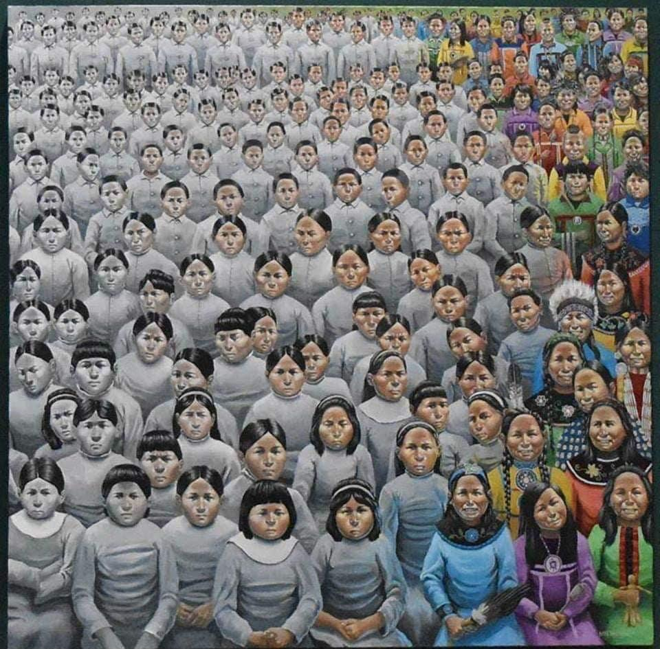

In this photo, it’s the indigenous people. The indigenous people getting their culture taken away from them. On the right they have colour, happiness, clothing, hair styled he way their culture likes so. As you go more to the left they all starts to change. They get more upset, their hair, and their clothing change and they start going more grey to represent their sadness of their culture getting taken away to how society back then wanted them to look like. Indigenous people had to go to residential schools, where they got sexually, physically and mentally abused. They weren’t allowed to speak their home language, they would cut their hair to how long they thought was okay, and they wouldn’t let them talk to siblings, leaving them to forget everything. Indigenous people had no choice but to go to the residential schools under the Canadian governments rules. If they were to wear, speak, or have anything from their culture they would get abused, however that would look for them. This photo is representing what they’ve been through and how their happiness and culture was taken away just because of racism.

