Name: Ashiana Sunderji BLK: D
Penny Lab
Purpose: To determine how many drops of water fit on one side of a
penny.
Hypothesis: If the liquid placed on the penny decreases the surface cohesion, then the penny will hold less drops of water because some substances can reduce the cohesion and the strength of the surface tension that water has naturally from its hydrogen and oxygen bond, if the elements do not attract.

Materials:
- 8 Canadian Pennies
- 4 paper towels
- Forceps
- Test dropper
- 20 mL of water
- 50 mL of soap solution
Procedure:
Part A: Perform a CONTROL test for comparison with later results.

Step 1: Rinse a penny in tap water and dry completely.
Step 2: Place the penny on paper towel.
Step 3: Use an eye dropper to place drops of WATER on the penny (one at a time) until ANY amount of water runs over the edge of the penny.
Step 4: Record the number of drops for that trial in the table.
Repeat Steps 1 - 4 three more times before calculating your average.

Number of drops  TRIAL 1 | Number of drops  TRIAL 2 | Number of drops  TRIAL 3 | Number of drops  TRIAL 4 | AVERAGE Number of drops
19 | 22 | 21 | 16 | 20

Part B: Perform tests with the TESTING LIQUID.

Step 1: Start with a “clean” penny. Rinse the penny in tap water and dry completely. Be sure to remove as much residue as possible - without using soap!
Step 2: Hold the penny with the tweezers provided, then dip it into the TESTING LIQUID. Allow extra liquid
to drip off the penny into the container before proceeding to the next step.
Step 3: Place penny on dry spot on a paper towel. Place drops of WATER on the penny (one at a time) until ANY amount of water runs over the edge of the penny.
Step 4: Record your observations and the number of drops for that trial in the table.
Repeat Steps 1 - 4 three more times before calculating the average.

TRIAL 1 | TRIAL 2 | TRIAL 3 | TRIAL 4 | AVERAGE
8 | 9 | 10 | 9 | 9
Observations:
Part One: Labelled Diagram of observations:  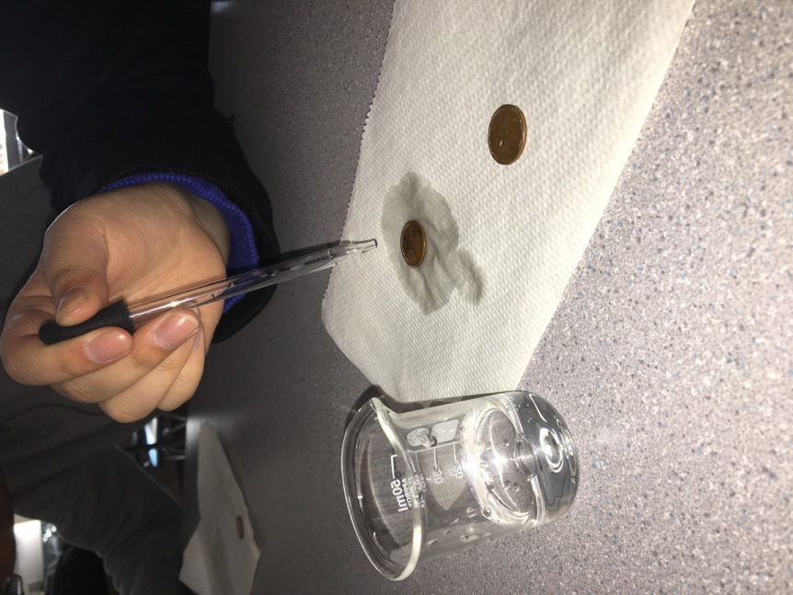 | Part Two: Labelled Diagram of observations: 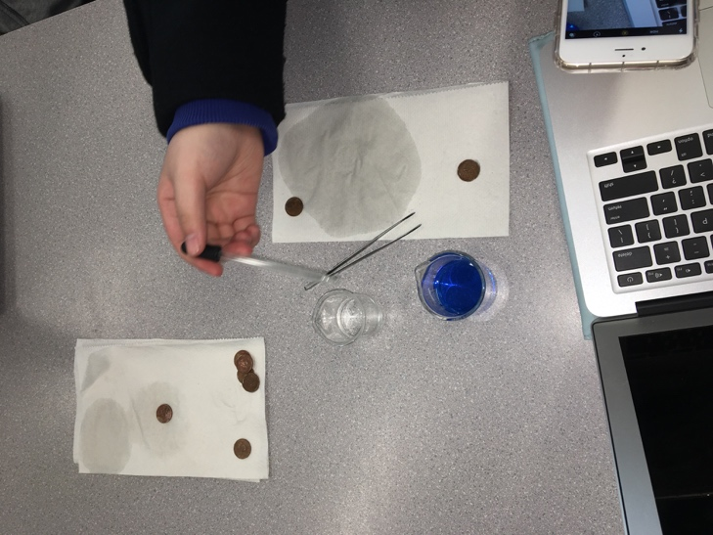  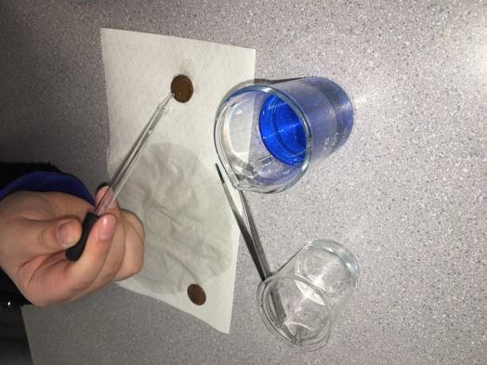
Description: This picture demonstrated the first part of the lab – where the ammount of drops of water that could be dropped onto a penny before spilling over was tested. The penny is washed, cleaned and dried before water is dropped onto it by a water droppper – so that it is certain that there are no traces of other substances on the penny.  Observations: •The “skin” or film developed onto the penny ressembled jello and formed a very curved 3 dimesional shape with water on the surface of the penny.  •The penny collected a significant ammount of water drops in comparison to part 2 of the lab.  •The paper towel absorbed the water.  •It was difficult at times for the water to come out of the dropper.  Inferences: Beccause water forms surface tension because of attraction, this allowed for the penny to hold more water dropes then to just cover the surface because of the bond between hydrogen and oxygen. | Description: This picture demonstrated the second part of the lab – where the ammount of drops of water that could be dropped onto a penny before spilling over was tested. The penny is washed, cleaned and then is dunked into a soapy solution prior to the test, which is the independent variable because part one did not have a soapy solution on the penny.  Obervations: •The “skin” developed did not ressemble as firm and strong,  •Bubbles were beginning to form on the surface of the penny when water drops were added.  •The colour of the water had a bluish under tone because of the soapy solution.  •The soap had a overly clean and chemical like smell.  Inferences: Because of the elements inside the soapy solutoin the surface tension was weakend because the attraction was not longer present between hydrogen, oxygen and the elements inside of the soapy solution.
Results:
Group # | Average Number of water Drops on the Control Penny | Average Number of Drops on the  Penny submersed in the soap solution
Group One | 20 | 9
Group Two | 25 | 8
Group Three | 26 | 6
Group Four | 23 | 7
Group Five | 22 | 9
Group Six | 14 | 5
Class Average: | 22 | 7

Conclusion:

This experiment investigated whether putting a soapy solution on the surface of a penny would weaken or strengthen the surface tension. In order to study this problem six table groups ran the experiment of first testing how many drops of water a penny, without anything on the surface, could hold on its surface. Then each group ran the test of how many drops of water a penny dunked into a soapy solution could hold on its surface. The tests were done four times per table to find a table average and then the table averages were added together and then divided for a class average. Results showed that on average a non-soapy penny could hold twenty-two drops of water and then when dunked in water the penny could only hold 7 drops of water. This proved that the hypothesis that if the liquid placed on the penny decreases the surface cohesion, then the penny will hold less drops of water because some substances can reduce the cohesion and the strength of the surface tension that water has naturally from its hydrogen and oxygen bond, was supported. The cohesion and surface tension did come into play for this experiment because a strong cohesion between hydrogen and oxygen was formed in the first part of the experiment as the only two elements that were combined had an attraction. The soapy solution consisted of elements that weakened the cohesion between the water drops and caused the surface tension to give out with less water drops added. The molecules in the soapy solution weakened the fluidity of the water as well as its ability to support pressure causing the pennies to spill the water quicker because of the lack of strength and ability to hold onto the pressure of water. The results of all the groups were, for the most part very similar because everyone was given the same materials and instructions so if the instruction were followed then the results would turn out the same. The reason that there were slight differences and a large difference between group 6 and the rest of the table groups could have been because of the way the pennies were washed prior, if one table group did not dry their pennies enough then their pennies would more likely hold less drops, the other reason for difference could be the amount of soap each penny was covered in because more soap would equal less drops of water.

To extend this experiment, it would be interesting to compare the number of drops of a different liquid compared to water to see which liquid has a higher surface tension. Another idea would be to test how many water drops other materials could hold, Canadian pennies are 94% steel so it would be interesting to see if the material that the water was being dropped on would change the amount of water drops being held for example if the material was aluminum or zinc for example. What would happen if the penny had been dunked into a different type of liquid instead of a soapy solution prior to the water being dropped on it, a comparison could be made for the affect that different solutions have on water’s surface tension.

This project can be used in the real-world to test out what kind of chemicals are harmful to the surface tension of the water in lakes and oceans, because a lack of surface tension can be of affect to marine life and the ecosystem. Cleaning products must encompass something that weakens the surface tension for water to be broken down, therefore in the making of cleaning products this experiment can come in use as it can help scientists to discover which chemicals, molecules and substances weaken or strengthen the surface tension of different liquids.

Questions about the experiment include whether there are chemicals that can strengthen surface tension. Do different climates of environment or different temperatures of water change the amount of water drops that a penny can hold? In other words, does temperature play a role in surface tension? Is surface tension relevant to other liquids, is it stronger, weaker or equal in other liquids than water? Would ocean water or salt water produce different results then the water that was used in this experiment? What chemicals were in the soapy solution that weakened the surface tension?

Finally, if the experiment was repeated, some changes to improve the experimental design could be to have an exact measurement of soapy solution to cover the surface as different amounts could have been used every time it was tested, also to measure the drops of water being placed because an observation was that sometimes the water would stick to the edge of the dropper and when it split onto the penny it would count as one drop, which was probably a smaller amount of water then other drops. Every group was asked to wash the pennies prior to the experiment, maybe if all the pennies had been washed and dried together it could have provided better results because some groups may have not cleaned them thoroughly or consistently and there is a possibility that chemicals touched the pennies prior to the experiment and were not properly washed off. There is also a possibility for students to have touched the pennies after they had been washed which could alter results.

