
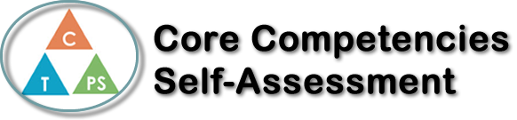
Name: Annabelle Ingelman | Date: June 23rd, 2022

  How does the artifact you selected demonstrate strengths & growth in the communication competency?  In what ways might you further develop your communication competency? | Self-Reflection  Describe how the artifact you selected shows your strengths & growth in specific core competencies. The prompt questions on the left - or other self-assessment activities you may have done - may guide your reflection process.  This reflection is based on The Lottery Infographic Assignment I did in English 11 Honours.  This infographic helped me develop Creative Thinking skills as I had to plan the design,  fonts, theme, colours, and words that would fit with the book. I enjoyed this project as it  combined art with English. I thought the short story The Lottery was interesting, sad, and  thought-provoking. It allowed me to reflect on the society we live in today and be grateful  for all that I have in this world. Overall, this infographic was a fun project because I got to  express my feelings on an English assignment through detailed artwork.

X

How does the artifact you selected demonstrate strengths & growth in the thinking competencies?

In what ways might you further develop your thinking competencies?


How does the artifact you selected demonstrate strengths & growth in the personal & social competencies?

In what ways might you further develop your personal & social competencies?
Publish Your Self Assessment
You will now attach and/or embed your self-assessment to the bottom of the blog post with the artifact you have chosen. You may choose to make this post private or public. After placing your artifact on a blog post, follow the instructions below.
- Categories - Self-Assessment
- Tags - Now tag your post using the tag that corresponds to the competency that you have written about. You can choose more than one. Please use lower case letters and be exact.
  - #creativethinkingcc
  - #communicationcc
  - #criticalthinkingcc
  - #socialresponsibilitycc
  - #personalidentitycc
  - #personalawarenesscc
- Use the Add Document button located at the top of your post page and embed your self-assessment at the bottom of your blog post.
- Publish

