
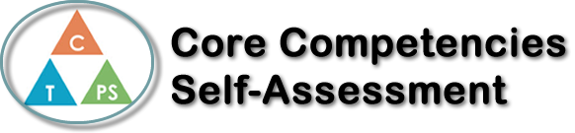
Name: Annabelle Ingelman | Date: July 31st, 2021

  How does the artifact you selected demonstrate strengths & growth in the communication competency?  In what ways might you further develop your communication competency? | Self-Reflection  Describe how the artifact you selected shows your strengths & growth in specific core competencies. The prompt questions on the left - or other self-assessment activities you may have done - may guide your reflection process.  The artifact I am writing about for this reflection is a spoken word poem I wrote in English  class, called “Someday”. This was a poem I created from scratch, about a personal issue in  my life that was important to me. I then read it out loud to the class during a presentation  day. I feel that the act of writing and presenting this poem helped me better my skills of  Personal Awareness and Responsibility, as well as Positive Personal and Cultural Identity.  Writing this spoken word taught me about myself, because it was on a personal issue in my  life. I really enjoyed doing this because I felt that writing down my feelings on a topic is a  great outlet of emotion. I began the process by just writing everything that came to my  mind, not worrying about if it rhymed or flowed like a real poem. Then later on, I went back  and edited it, to make sure it sounded good and fit the correct criteria for the assignment.  I developed Positive Personal and Cultural Identity because I found that writing poems is  something I enjoy and am good at. Although I was nervous to present it to my class, I  realized that I am really passionate about writing spoken words, especially when it is about a  topic I feel is very important. This assignment helped me learn about myself on a deeper  level, and discover something interesting about my personal identity.


How does the artifact you selected demonstrate strengths & growth in the thinking competencies?

In what ways might you further develop your thinking competencies?

X

How does the artifact you selected demonstrate strengths & growth in the personal & social competencies?

In what ways might you further develop your personal & social competencies?

Publish Your Self Assessment
You will now attach and/or embed your self-assessment to the bottom of the blog post with the artifact you have chosen. You may choose to make this post private or public. After placing your artifact on a blog post, follow the instructions below.
- Categories - Self-Assessment
- Tags - Now tag your post using the tag that corresponds to the competency that you have written about. You can choose more than one. Please use lower case letters and be exact.
  - #creativethinkingcc
  - #communicationcc
  - #criticalthinkingcc
  - #socialresponsibilitycc
  - #personalidentitycc
  - #personalawarenesscc
- Use the Add Document button located at the top of your post page and embed your self-assessment at the bottom of your blog post.
- Publish

