
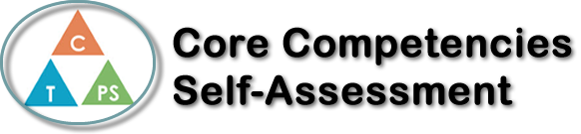
Name: Annabelle Ingelman | Date: July 31st, 2021

  X  How does the artifact you selected demonstrate strengths & growth in the communication competency?  In what ways might you further develop your communication competency? | Self-Reflection  Describe how the artifact you selected shows your strengths & growth in specific core competencies. The prompt questions on the left - or other self-assessment activities you may have done - may guide your reflection process.  This reflection is on a presentation I did in CLE 10, called “All About Me”. For this  presentation I created a PowerPoint that described my likes, dislikes, interests, and lots of  other information about who I am. The purpose of this assignment was to tell the teacher  and other students a bit about myself, so they could get to know me better. I also got to  learn about my classmates when they did their own presentations. This project helped me to  develop better skills in the Communication Core Competency.  I worked on my Communication skills by acquiring information about myself. I was given a list of criteria to follow for the presentation, so I started by finding all of this information about myself and writing it down. I asked my parents for help on some words to describe me. Then I created the presentation and made sure it was interesting and visually appealing for the audience.  I also had to connect with my class by explaining the slides on the PowerPoint as I shared it with them. This was a bit stressful for me because presenting isn’t my favourite thing, but I got through it and was proud of myself in the end. Overall, I think I made an awesome presentation, that can even be used again in the future to tell people all about me.


How does the artifact you selected demonstrate strengths & growth in the thinking competencies?

In what ways might you further develop your thinking competencies?


How does the artifact you selected demonstrate strengths & growth in the personal & social competencies?

In what ways might you further develop your personal & social competencies?

Publish Your Self Assessment

You will now attach and/or embed your self-assessment to the bottom of the blog post with the artifact you have chosen. You may choose to make this post private or public. After placing your artifact on a blog post, follow the instructions below.
- Categories - Self-Assessment
- Tags - Now tag your post using the tag that corresponds to the competency that you have written about. You can choose more than one. Please use lower case letters and be exact.
  - #creativethinkingcc
  - #communicationcc
  - #criticalthinkingcc
  - #socialresponsibilitycc
  - #personalidentitycc
  - #personalawarenesscc
- Use the Add Document button located at the top of your post page and embed your self-assessment at the bottom of your blog post.
- Publish

