
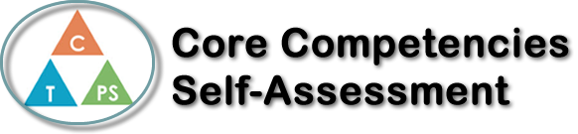
Name: Annabelle Ingelman | Date: July 30th, 2021

  How does the artifact you selected demonstrate strengths & growth in the communication competency?  In what ways might you further develop your communication competency? | Self-Reflection  Describe how the artifact you selected shows your strengths & growth in specific core competencies. The prompt questions on the left - or other self-assessment activities you may have done - may guide your reflection process.  This reflection is based on my mood board project from my Textiles 11 course. For this  project, I was asked to choose any topic I wanted and make a mood board that followed  certain criteria. I loved this project because I got to be completely creative, and use multiple different types of art. This was a way for me to work on my Critical and Creative Thinking.  When I was planning out the mood board I used a lot of Critical Thinking. I developed the theme first, which was a “Paris flower shop”. Then I did some research for ideas on the design. I created a Word document and filled it with photos I found online that fit my theme. Then I went through and edited them to choose the best-fitting ones. These were used as my inspiration when I was creating the pieces for my mood board. After that, I followed the criteria my teacher had given me, by doing 4 drawings and including fabric swatches, ribbon, buttons, and other 3D decorations.  To design the layout I used Creative Thinking in many ways. I decided to paint part of the background to look like the Eiffel Tower, and then covered the rest in old newspaper which fit the theme. I added some tissue paper on top to make it more translucent and made some tissue paper flowers as decorations. I loved how the ideas I had created in my head came to life in a physical thing. Overall, I was very happy with the final result of this project, and I would definitely do it again with another theme!

X

How does the artifact you selected demonstrate strengths & growth in the thinking competencies?

In what ways might you further develop your thinking competencies?


How does the artifact you selected demonstrate strengths & growth in the personal & social competencies?

In what ways might you further develop your personal & social competencies?

Publish Your Self Assessment
You will now attach and/or embed your self-assessment to the bottom of the blog post with the artifact you have chosen. You may choose to make this post private or public. After placing your artifact on a blog post, follow the instructions below.
- Categories - Self-Assessment
- Tags - Now tag your post using the tag that corresponds to the competency that you have written about. You can choose more than one. Please use lower case letters and be exact.
  - #creativethinkingcc
  - #communicationcc
  - #criticalthinkingcc
  - #socialresponsibilitycc
  - #personalidentitycc
  - #personalawarenesscc
- Use the Add Document button located at the top of your post page and embed your self-assessment at the bottom of your blog post.
- Publish

