
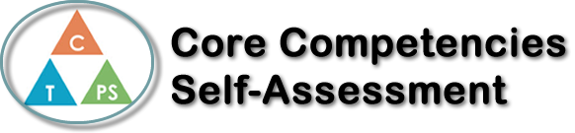
Name: Annabelle Ingelman | Date: July 30th, 2021

  X  How does the artifact you selected demonstrate strengths & growth in the communication competency?  In what ways might you further develop your communication competency? | Self-Reflection  Describe how the artifact you selected shows your strengths & growth in specific core competencies. The prompt questions on the left - or other self-assessment activities you may have done - may guide your reflection process.  The artifact I chose is my partner project from Science 10 Honours. This project was called “Science is Magic”, where we created a video of a science experiment that looked like a magic trick. Since this was a partner project, I feel that I worked on the Communication Core Competency the most.  Connecting with my partner was very important so we could come up with an idea for the project that we both liked. We started out with many ideas and then narrowed it down together to one we found interesting, and also that we were capable of doing. I had to make sure to communicate my ideas clearly, so my partner knew what I wanted to do, but also include their ideas as well. We both contributed equally to this project and worked well together.  The video presentation was another aspect of this project that helped develop my Communication skills. Together with my partner, we filmed and edited a video to share as our presentation. This involved us talking to each other and planning out the best way to film it. We ended up filming our own parts separately at home, then editing them into one video. This was a great way for us to work together but still be safe during covid.  Overall, my “Science is Magic” project was an important part of my science course because it was a way in which I gained better communication skills. I also learned a lot and got to make a fun video with a partner!


How does the artifact you selected demonstrate strengths & growth in the thinking competencies?

In what ways might you further develop your thinking competencies?


How does the artifact you selected demonstrate strengths & growth in the personal & social competencies?

In what ways might you further develop your personal & social competencies?

Publish Your Self Assessment
You will now attach and/or embed your self-assessment to the bottom of the blog post with the artifact you have chosen. You may choose to make this post private or public. After placing your artifact on a blog post, follow the instructions below.
- Categories - Self-Assessment
- Tags - Now tag your post using the tag that corresponds to the competency that you have written about. You can choose more than one. Please use lower case letters and be exact.
  - #creativethinkingcc
  - #communicationcc
  - #criticalthinkingcc
  - #socialresponsibilitycc
  - #personalidentitycc
  - #personalawarenesscc
- Use the Add Document button located at the top of your post page and embed your self-assessment at the bottom of your blog post.
- Publish

