
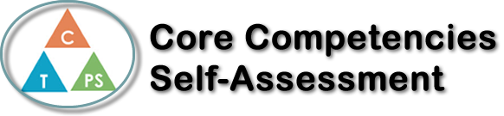
Name: Annabelle Ingelman | Date: July 17th, 2020

  How does the artifact you selected demonstrate strengths & growth in the communication competency?  In what ways might you further develop your communication competency? | Self-Reflection  Describe how the artifact you selected shows your strengths & growth in specific core competencies. The prompt questions on the left - or other self-assessment activities you may have done - may guide your reflection process.  At the end of the year in Math 9, I completed some virtual escape rooms that helped me develop both Critical and Creative Thinking skills. I chose those escape rooms as the artifact that I wanted to talk about for this core competency reflection.  Since this assignment was done online, it was a new experience for me. I have done escape rooms in real life before, but this was different as it was all done through technology. I was able to use my Critical Thinking skills in the escape rooms by analyzing and solving the math questions. I used information and knowledge I had learned earlier in the year during Math 9 to complete some of the escape rooms. I also feel that I grew in my Critical Thinking skills, because when some of the questions were challenging, I found ways to solve them.  I used Creative Thinking in this assignment, to figure out new ways of doing things online. I learned that escape rooms can still be possible through technology, when real escape rooms aren’t open. These escape rooms were not only fun and interesting, but a great way for me to practice and learn math skills. They also showed me that it is possible to do so many different things online.

X

How does the artifact you selected demonstrate strengths & growth in the thinking competencies?

In what ways might you further develop your thinking competencies?


How does the artifact you selected demonstrate strengths & growth in the personal & social competencies?

In what ways might you further develop your personal & social competencies?

