
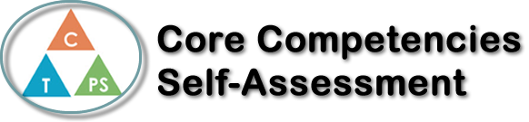
Name: Anita Shahriary | Date: 4/21/2021

  How does the artifact you selected demonstrate strengths & growth in the communication competency?  In what ways might you further develop your communication competency? | Self-Reflection  Describe how the artifact you selected shows your strengths & growth in specific core competencies. The prompt questions on the left - or other self-assessment activities you may have done - may guide your reflection process.  How has your understanding of your strengths and abilities changed since the beginning of the quarter?  This has helped me narrow down my choices for the career I want to follow, even though I am still not certain which one I want to pick. I want to make use of as many of my abilities as possible when working and showcase the best of them. The jobs I have picked are now influenced by my abilities and strengths as a result.  How have your plans concerning your future shifted, if at all, over the course of the quarter?  I am now less confused when thinking about my future since I have taken out a few of the career paths I was interested in taking. For example, I was interested in becoming a dentist before researching the type of abilities it requires and the education needed. I no longer want to have it as my career since I would need to be interested in biology, which is my least favorite science branch.  Concerning your future, in what areas do you still feel uncertain about? How can you address these areas?  I am still not sure about what career to pick, since I am interested in teaching, engineering, and music. The jobs I am interested in are very different and I will not be able to incorporate all of them into my life. I am leaning towards engineering, but I am worried that I will regret my choice in the future.  The project that I have chosen is my autobiography video. This video show my values and it represents me as an individual, so it is perfect to showcase my growth throughout this course.


How does the artifact you selected demonstrate strengths & growth in the thinking competencies?

In what ways might you further develop your thinking competencies?



How does the artifact you selected demonstrate strengths & growth in the personal & social competencies?

In what ways might you further develop your personal & social competencies?

Publish Your Self Assessment
You will now attach and/or embed your self-assessment to the bottom of the blog post with the artifact you have chosen. You may choose to make this post private or public. After placing your artifact on a blog post, follow the instructions below.
- Categories - Self-Assessment
- Tags - Now tag your post using the tag that corresponds to the competency that you have written about. You can choose more than one. Please use lower case letters and be exact.
  - #creativethinkingcc
  - #communicationcc
  - #criticalthinkingcc
  - #socialresponsibilitycc
  - #personalidentitycc
  - #personalawarenesscc
- Use the Add Document button located at the top of your post page and embed your self-assessment at the bottom of your blog post.
- Publish

