WHITE OWL
White owl
Hear my call
I’ve lost the will to live
Kind of fell apart
My son is gone
And so am I
My spirit lost
To the mountain high

I’ll help you,
But you must be strong
If we are to fix
This deadly wrong

We must make you lighter
That heaviness you feel
Of grief
And
Fear

Greet each new day
Cleanse and bathe
Background Image: Courtesy of Georgia Combes,
http://publications.ravenspacepublishing.org/as-i-remember-it/toba-inlet-mountain-range--brem-river-valley-9
White Owl Image: Courtesy of MCF Tech, https://www.mcftech.com/about-mcftech/
The pain will fade
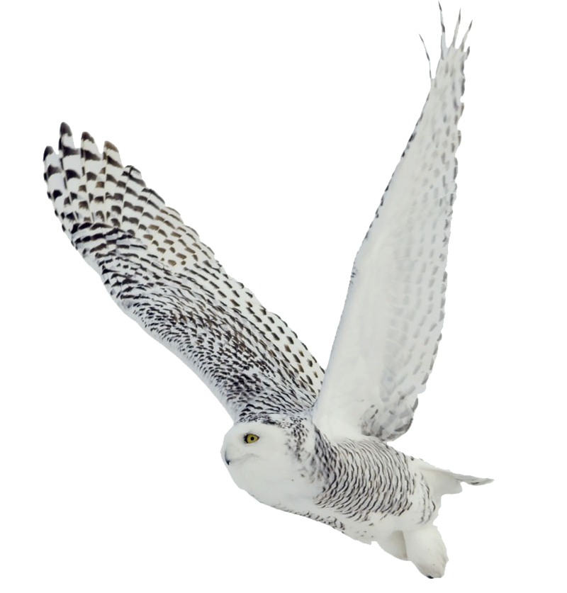
Losing someone
Made you sick
But this self-healing
Will do the trick.

White owl
Hear my call
I’ve lost the will to live
Kind of fell apart
But I greet each day
And protect my spirit
For I shall live
Each day with merit

By Ammarah Siddiqui
(adapted from “He Got His Spirit Back” by Elsie Paul)

