
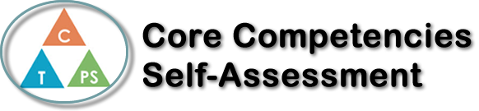
Name: Ammarah Siddiqui | Date: June 3, 2020

  How does the artifact you selected demonstrate strengths & growth in the communication competency?  In what ways might you further develop your communication competency? | Self-Reflection  Describe how the artifact you selected shows your strengths & growth in specific core competencies. The prompt questions on the left - or other self-assessment activities you may have done - may guide your reflection process.  We were given a COVID – 19 Time Capsule Reflection booklet to complete and at first I didn’t think that I would have much to write. Turns out I was very much wrong. Asking questions about what we are going through at both a surface level and feelings wise the reflection booklet really made me think about the situation and how it is making me feel. I practiced my personal awareness core competency immensely as I reflected and thought about how I was feeling and emotions that have bubbled up to the surface going through this pandemic. My personal and social competencies were also further developed as I wrote about the different things I was doing to stay connected with my community, family, and friends as well as do my social responsibility and promote positive messages about peace and unity espescially during this trying time. I learned about comprehending the situation and understanding the far-reaching impacts that it has on my life and billions around the world as it is a worldwide pandemic. The booklet made me realize that I truly am living through history and it is more important than ever to focus on not only the big picture but the smaller things in life that make a big difference. To take into consideration my feelings, emotions, and general mental wellbeing practicing personal awareness. It also helped solidify my identity aspects as I realized the things that I may take for granted on a daily basis that I may see as rights, but they truly are privileges. This booklet helped me grow my personal awareness and identity as well as social responsibility competencies.


How does the artifact you selected demonstrate strengths & growth in the thinking competencies?

In what ways might you further develop your thinking competencies?

X

How does the artifact you selected demonstrate strengths & growth in the personal & social competencies?

In what ways might you further develop your personal & social competencies?

Publish Your Self Assessment
You will now attach and/or embed your self-assessment to the bottom of the blog post with the artifact you have chosen. You may choose to make this post private or public. After placing your artifact on a blog post, follow the instructions below.
- Categories - Self-Assessment
- Tags - Now tag your post using the tag that corresponds to the competency that you have written about. You can choose more than one. Please use lower case letters and be exact.
  - #creativethinkingcc
  - #communicationcc
  - #criticalthinkingcc
  - #socialresponsibilitycc
  - #personalidentitycc
  - #personalawarenesscc
- Use the Add Document button located at the top of your post page and embed your self-assessment at the bottom of your blog post.
- Publish

