
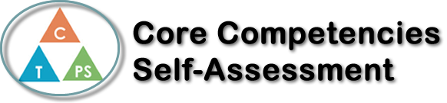
Name: Alyssa | Date: November 2nd, 2022

   | Collaboration Self-Reflection  - Describe your current collaboration strengths. Use specific examples.  - How has your collaboration improved in Co-op? What are you proud of? Provide specific examples.  - Identify an area for future growth in collaboration.  My collaboration strengths include showing all my steps so everyone understands my thought process, and not making others feel bad about making mistakes. When at whiteboards, I write out each step to the question and check in with my group members to make sure everyone understands. As well when I or someone else makes a mistake I try my best to use it as a learning opportunity and not make anyone feel bad about it.  My sense of comfort in working with new people has improved since I started Co-Op. I am most proud of my positive attitude towards working in groups and my efforts to make everyone feel included. For example, while at whiteboards I try to keep it light-hearted and check in with my group members frequently.  An area I can improve on is posing questions when I don’t fully understand. Sometimes I feel as if I will be judged for not knowing something or feel as if I’m interrupting the group. I am trying my best to step out of my comfort zone as well as trying to make others feel comfortable asking questions too.




Publish Your Self Assessment
You will now attach and/or embed your self-assessment to the bottom of the blog post with the artifact you have chosen. You may choose to make this post private or public. After placing your artifact on a blog post, follow the instructions below.
- Categories - Self-Assessment
- Tags - Now tag your post using the tag that corresponds to the competency that you have written about. You can choose more than one. Please use lower case letters and be exact.
  - #creativethinkingcc
  - #communicationcc
  - #criticalthinkingcc
  - #socialresponsibilitycc
  - #personalidentitycc
  - #personalawarenesscc
- Use the Add Document button located at the top of your post page and embed your self-assessment at the bottom of your blog post.
- Publish

