
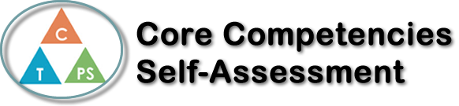
Name: Alisha Kwon | Date: Nov. 8th ,2023

  How does the artifact you selected demonstrate strengths & growth in the communication competency?  In what ways might you further develop your communication competency? | Self-Reflection  Describe how the artifact you selected shows your strengths & growth in specific core competencies. The prompt questions on the left - or other self-assessment activities you may have done - may guide your reflection process.  During the econ map project in Economics 12, I have demonstrated my critical and creative thinking skills. Within all the lessons we learned about economics, we had to make a map to present my knowledge on economics visually. To clearly organize excessive amount of information, I deeply engage with my creative thinking skills to create an informative but also easy to follow map. In terms of information, I used my knowledge on what we have learned so far and demonstrated short and clear definitions and examples of all the terms. Then, most importantly, I critically reflected on how these different terms and laws are connected.


How does the artifact you selected demonstrate strengths & growth in the thinking competencies?

In what ways might you further develop your thinking competencies?


How does the artifact you selected demonstrate strengths & growth in the personal & social competencies?

In what ways might you further develop your personal & social competencies?

Publish Your Self Assessment
You will now attach and/or embed your self-assessment to the bottom of the blog post with the artifact you have chosen. You may choose to make this post private or public. After placing your artifact on a blog post, follow the instructions below.
- Categories - Self-Assessment
- Tags - Now tag your post using the tag that corresponds to the competency that you have written about. You can choose more than one. Please use lower case letters and be exact.
  - #creativethinkingcc
  - #communicationcc
  - #criticalthinkingcc
  - #socialresponsibilitycc
  - #personalidentitycc
  - #personalawarenesscc
- Use the Add Document button located at the top of your post page and embed your self-assessment at the bottom of your blog post.
- Publish

