
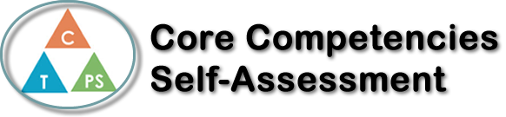
Name: Alexis Wallace | Date: September 24th 2019

  How does the artifact you selected demonstrate strengths & growth in the communication competency?  In what ways might you further develop your communication competency? | Self-Reflection  Describe how the artifact you selected shows your strengths & growth in specific core competencies. The prompt questions on the left - or other self-assessment activities you may have done - may guide your reflection process.  Thinking  Two types of thinking is creative and critical. This year in ceramics so far we have used both types of thinking. What is Creative thinking? Creative thinking is when someone has the ability to think outside of the box and come up with their own unique ideas. Creative thinkers are very good at using their imagination to come up with new ideas or improve old ones. We have used creative thinking this year when we made our sphere projects. We had to use our imagination to come up with our own ideas to try and transform our spheres into something unique. We had to add things on to our project to make the sphere into something totally different. Critical thinking is different type of thinking but it is also very important. A critical thinker is someone that pays attention to detail, challenges their own ideas, and someone who thinks before they act. An example of us thinking critically this year is when we made our ocarina. we had to plan out what kind of shape we wanted to make and we had to pay lots of attention to detail because we had to make sure that our ocarina would work.

X

How does the artifact you selected demonstrate strengths & growth in the thinking competencies?

In what ways might you further develop your thinking competencies?


How does the artifact you selected demonstrate strengths & growth in the personal & social competencies?

In what ways might you further develop your personal & social competencies?

Publish Your Self Assessment
You will now attach and/or embed your self-assessment to the bottom of the blog post with the artifact you have chosen. You may choose to make this post private or public. After placing your artifact on a blog post, follow the instructions below.
- Categories - Self-Assessment
- Tags - Now tag your post using the tag that corresponds to the competency that you have written about. You can choose more than one. Please use lower case letters and be exact.
  - #creativethinkingcc
  - #communicationcc
  - #criticalthinkingcc
  - #socialresponsibilitycc
  - #personalidentitycc
  - #personalawarenesscc
- Use the Add Document button located at the top of your post page and embed your self-assessment at the bottom of your blog post.
- Publish

