
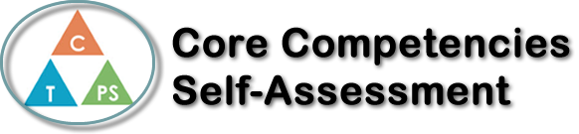
Name: Alexis Hart | Date: 2022-01-07

  How does the artifact you selected demonstrate strengths & growth in the communication competency?  In what ways might you further develop your communication competency? | Self-Reflection  Describe how the artifact you selected shows your strengths & growth in specific core competencies. The prompt questions on the left - or other self-assessment activities you may have done - may guide your reflection process.  This project allowed me to show my better understanding of the Environment and things found in our environment. Say for example when I looked at specific mushrooms, I never thought much of it but when I looked in more depth and learned more about the mushrooms it opens a whole new portal of knowledge for me  This artifact shows my strengths because one of the best ways I know how to show my knowledge is by projects. I Like projects as a way for me to present my knowledge the best because it slows met show what I have learned but in a creative way as well.  I think I can just further my social skills by showing different ways of knowledge


How does the artifact you selected demonstrate strengths & growth in the thinking competencies?

In what ways might you further develop your thinking competencies?


How does the artifact you selected demonstrate strengths & growth in the personal & social competencies?

In what ways might you further develop your personal & social competencies?

Publish Your Self Assessment
You will now attach and/or embed your self-assessment to the bottom of the blog post with the artifact you have chosen. You may choose to make this post private or public. After placing your artifact on a blog post, follow the instructions below.
- Categories - Self-Assessment
- Tags - Now tag your post using the tag that corresponds to the competency that you have written about. You can choose more than one. Please use lower case letters and be exact.
  - #creativethinkingcc
  - #communicationcc
  - #criticalthinkingcc
  - #socialresponsibilitycc
  - #personalidentitycc
  - #personalawarenesscc
- Use the Add Document button located at the top of your post page and embed your self-assessment at the bottom of your blog post.
- Publish

