Mr. Barrington/Mr. Robinson Aleana Labrador
COL 10/01/16
Digital Footprint

How might your digital footprint affect your future opportunities? Give at least two examples.
One of the two examples that a digital footprint may affect someone’s future opportunities is that:
- They’re have been many stories when people have decided to share, post, or search up something inappropriate online and later on deleting or “clearing” the history, and expecting it to be gone, just like that. What most of these failed to realise is that once you have put something online it will never disappear. This can lead to losing future jobs. According to the research “The Lance” have done based on what “The Career Builders” have said is that when applying for a job 63% of the hiring managers have said that they would rather not hire someone with a digital footprint with anything that may question their professional level. This means that a high percentage of workplaces do look at what you have been up to with your digital footprint, therefor just think, is it really worth possibly ruining your future opportunities.
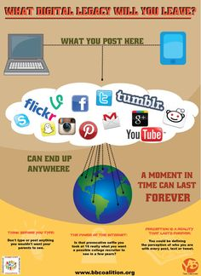
- A very good example of how a digital footprint can effect someone’s future opportunities is Mike Bacsik, a former major league pitcher after having lost his game he took his anger to social media twitter in this case and he had made a racial tweet. At first Mike had been suspended, then later on they had decided to fire him. Mike had probably worked so hard to get where he was, but because of one inconsiderate post he made he lost his job. And even though he had deleted the comment from his twitter you can still find what he had posted online, because no matter what, what goes on the internet stays on there forever.

Describe at least three strategies that you can use to keep your digital footprint appropriate and safe.
Three strategies that I can use to keep my digital footprint appropriate and safe is:
- I can avoid social media when I am upset, mad or angry to keep me from texting or posting something I can regret later. In these times log out of my social media and hand my technologies to someone I have complete trust in to give it back to me when I have calmed down.

- I will always think before I post, is it something that may affect me in the future? If it’s something that I would not want my parents to see I would not post it.

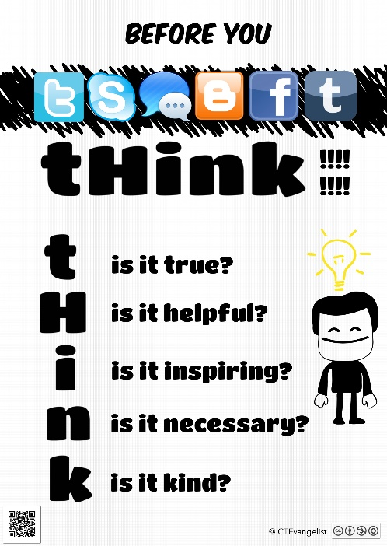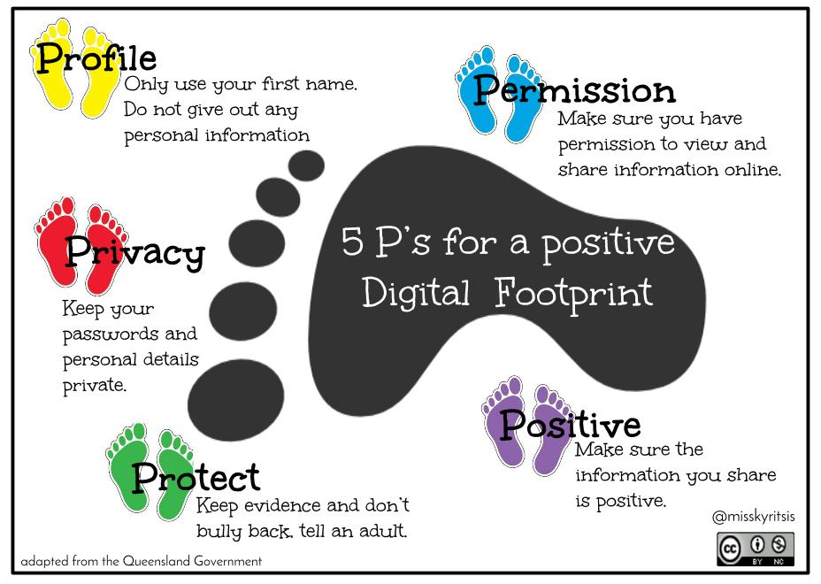
- I will always be aware about how much personal information I am putting online. And when I am signing up for any social media I will make sure to read everything, because there are times where you do not have to put down the information it says to put down. I can make sure to have a different password for each social media account. I can also avoid telling others the passwords to my account.

What information did you learn that you would pass on to other students? How would you go about telling them?
Something I would probably tell other students is that just because you think it’s a good idea at the time doesn’t mean it will be a week from now or a month or even a year. It’s better to be safe then sorry when it come to things online. And no matter what you try to do it’s impossible to get something off the internet. I would also tell them to watch how much information they put out there about themselves, putting too much information can be dangerous.
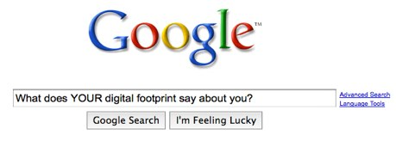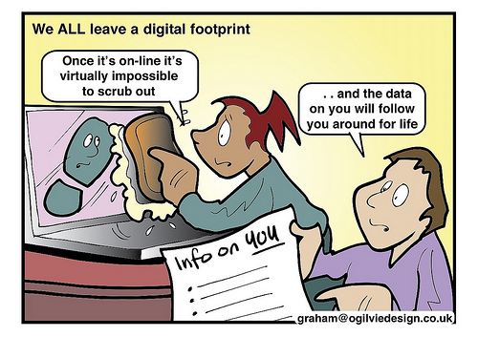

How might your digital footprint affect your future opportunities? Give at least two examples.
http://lhslance.org/2015/news/digital-footprints-will-posts-affect-future/
http://www.rollingstone.com/culture/lists/a-brief-history-of-people-getting-fired-for-social-media-stupidity-20150713/the-radio-jock-who-tweeted-about-dirty-mexicans-20150713
Describe at least three strategies that you can use to keep your digital footprint appropriate and safe.
http://www.granvillecsd.org/webpages/lgrandjean/using_the_internet.cfm?subpage=635376

Photos
https://kurtishewson.wordpress.com/2011/10/28/evolution-of-digital-footprints/
https://s-media-cache-ak0.pinimg.com/236x/30/4b/15/304b154c4167ce8016e8b1551d934000.jpg
https://ictevangelist.com/wp/wp-content/uploads/2013/04/Digital-Citizenship-1.jpg
https://elenikyritsis.files.wordpress.com/2015/11/5-ps-for-a-positive-digital-footprint.jpg
https://www.tes.com/lessons/mUL13Tdmi8vhbg/6-unit-4-internet-safety_lesson-2
http://langwitches.org/blog/wp-content/uploads/2009/09/Google-digital-footprint-1.jpg

