MY THOUGHTS ON MARRIAGE
Answer the following questions with the first thoughts that pop into your head.
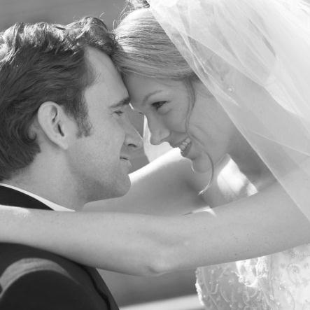
- To me marriage means…

- People marry because…

- The most important factor in a marriage is…

- Some marriages succeed because…

- Some marriages fail because…

- Marriage is / is not one of my life goals because…

- I expect my marriage to be…

- The ideal age for me to marry is ___________ because…

- My opinions on marriage have been most influenced by…

- The most important contributions I will make to my marriage are…

- 6 words to describe my ideal marriage partner are…

- It is / is not important that my family accepts my future mate because…

- Three interests that I hope to share with my future mate are…

- A prenuptial agreement is…

- I would / would not like to have a prenuptial agreement because…

