REFLEXES

Reflexes are a newborns ______________ ______________. These movements are ___________________ that is, the baby has no control over them. Reflexes are important because they are a good indicator of a newborn’s_______________. These reflexes only last a short time; they are soon replaced by _______________ ________________.

MOTOR SKILLS

Motor skill refers to ____________________. Motor skills are abilities that depend upon the use and control of _________________. A newborn has little control over his body. He must develop __________________, ___________________, __________________ and ________________. These develop with _________________ and ___________________. One of the first motor skills infants must acquire is control of the _________________. At birth, the head is ________________ and________________; the neck muscles are _______________. Newborns progress from lifting their head ________________ to lifting both __________ and ____________. By three months they can hold their head ______________ when in a seated position. Motor skills continue to develop in a ___________________pattern. ______________ have been developed which illustrate normal development.

Small _____________ Motor Skills: small number of muscles to make______________ movement

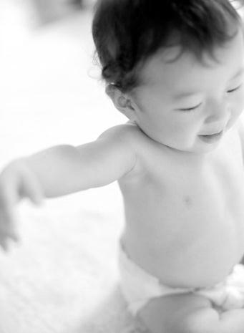
Large _____________ Motor Skills: many muscles used to make _________________ movements

REFLEXES IN INFANCY

REFLEX | DESCRIPTION | DURATION
SUCKING | When a nipple or finger is inserted into the infant’s mouth, rhythmic sucking occurs. | Changes to voluntary sucking by 2 months
ROOTING

PALMER GRASP

MORO/STARTLE

BABINSKI

TONIC NECK

STEPPING

RIGHTING

SWIMMING

