**PHYSICAL GROWTH AND DEVELOPMENT**

**Patterns of Physical Development**

Physical development proceeds in the same ________________________ order for every baby. It follows three basic patterns:

* Head to __________________:

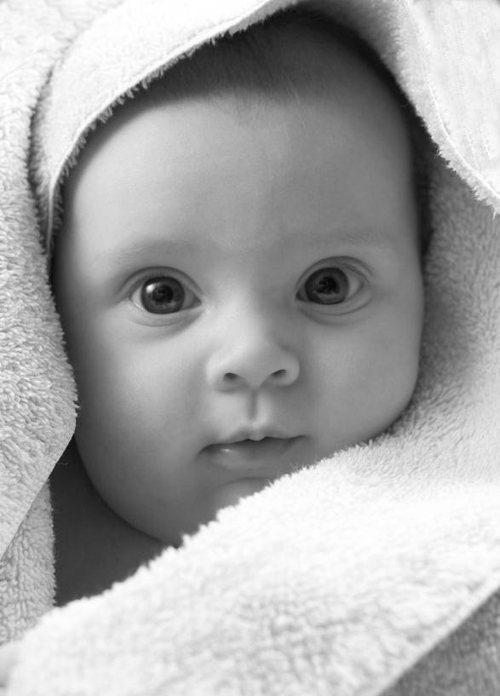

* + Head leads in development (this is why head is large)
  + Develop ability to lift head first
* Near to __________________:
  + From trunk outwards (ex. Body-arms-hands-fingers)
* Simple to _________________:
  + Being fed – eating wit fingers – using a spoon

**Growth During the First Year**

Children grow and develop at _____________________ rates.

Charts are available that show average ___________, ____________ and __________ at certain ages – remember though that very few babies are “_________________”.

**Weight**

Weight gain is one of the best indications of ___________________________.

Most babies experience a slight weight ___________ just after birth and then begin to gain weight _________________.

The average birth weight is ________; the average one year old weights ___________.

C:\Users\alazar\AppData\Local\Microsoft\Windows\Temporary Internet Files\Content.IE5\RXGYIXY0\MC900330190[1].wmf

**Height**

Growth in height is ____________________ during the first year.

The average newborn is _________ inches long and by one year is ________ inches.

_______________ influences height more than weight.

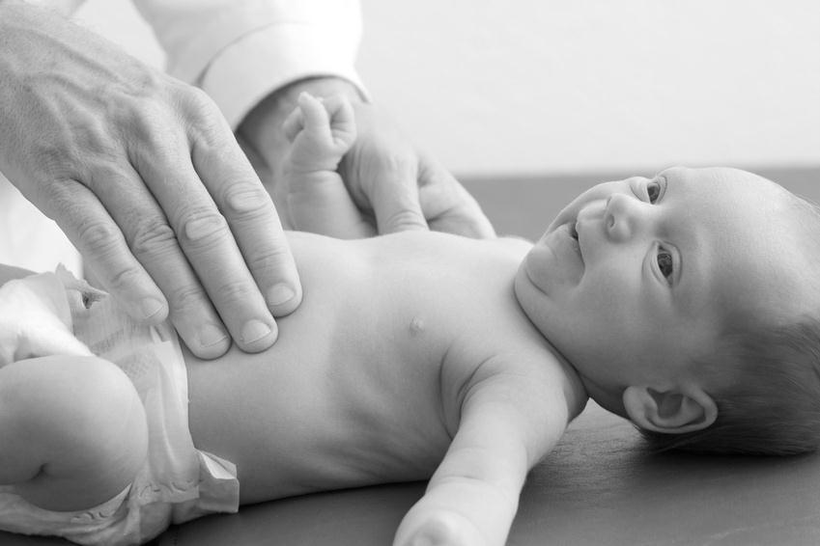

**Proportion**

In child development, proportion refers to the size relationship between different body parts.

The __________________ continues to grow rapidly during the first year.

Compared to an adult, a baby’s head and abdomen are ____________ and the legs and arms are ____________ and ____________.