**PERSONALITY**

Personality is the total of all the specific ___________ that are consistent in an individual’s behavior.

To be consistent, the characteristics must be present over a period of ________ and in a variety of _________________.

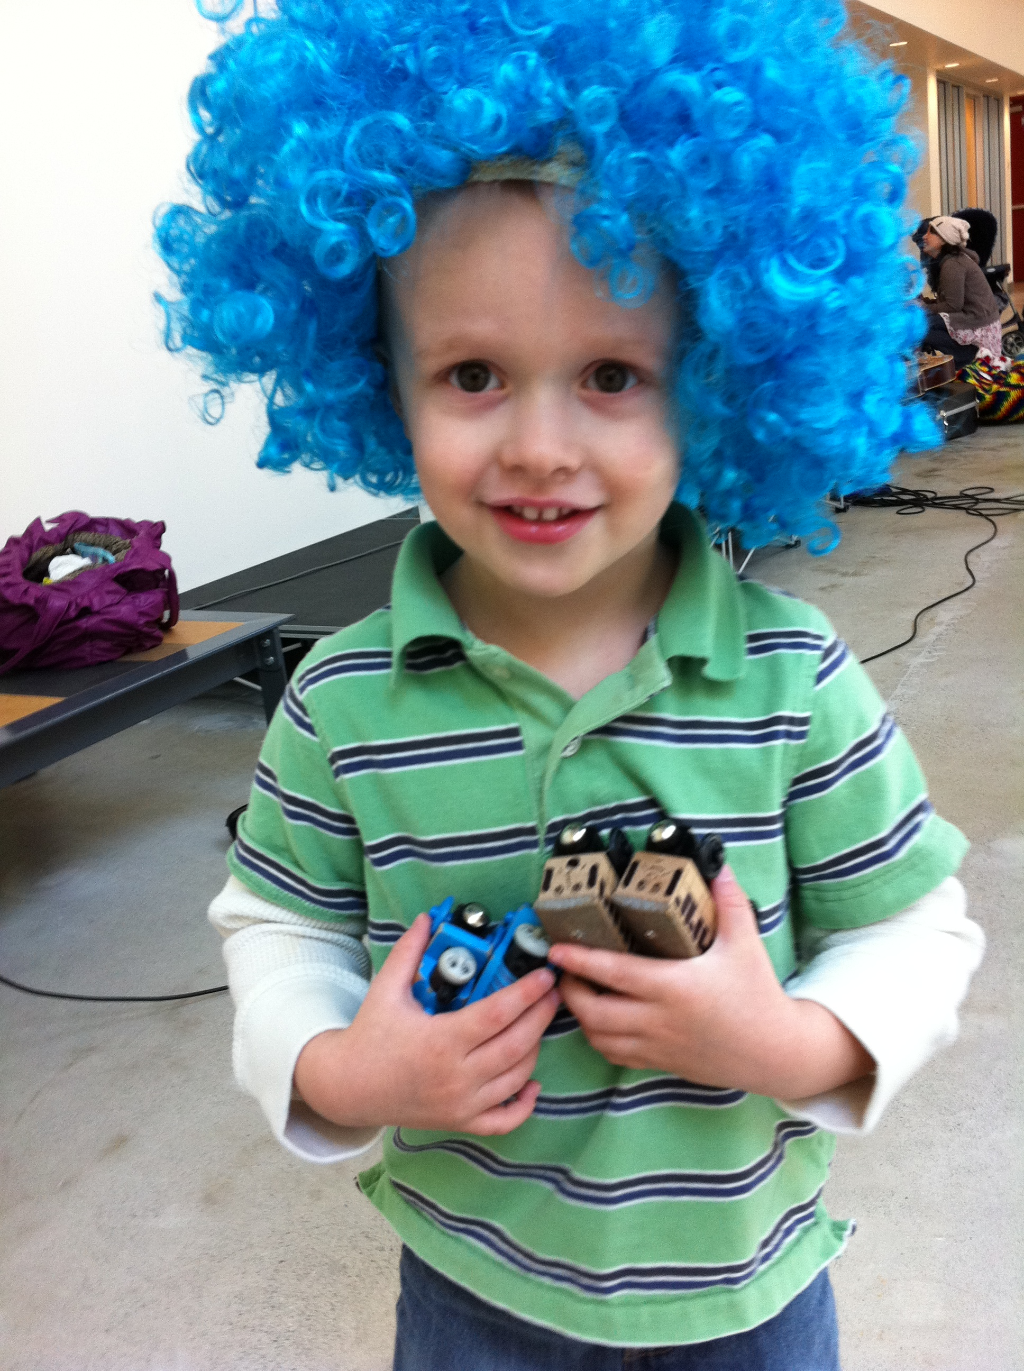

There are many personality traits.

**Influences on Personality**

1. Family
2. Environment
   * Personality is also influenced by a child’s ___________________
   * Those who are ________________, ________________, and ________________ develop a positive self-concept
   * Those who are _______________ or negatively compared with others develop a ________________ self-concept

**Common Personality Patterns**

**The Sensitive Child**

* Unusually aware of _________________ in surroundings
* Cry _____________/Difficult to ________________
* Need extra _____________ and attention
* Parents must be ­­­­­­­­­­_______________ and __________________ in order to develop positive self-concept

**The Placid Child**

* Easygoing and __________________ of surroundings
* Less upset by ________________ changes than other types
* Adjust _________________ to new people
* Friendly and patient
* Parents must be sure to give them ________________________ even though they seem not to need it

**The Aggressive Child**

* Unusually _____________________ and determined
* Love activity and are not concerned with _______________ – they keep trying
* _________________ are common
* Parents must react quickly and _____________________
* Parents should also provide love, affection, and _____________ attention